Schedule 6
Pondicherry (Part) Precinct

ISSUE: RevG - Post Exhibition (October 2021)

Contents
1. Introduction 4
1.1 Name and Application of this Schedule 4
1.2 Structure of this Schedule 4
2. Subdivision Planning and Design 6
2.1 Pondicherry (Part) Precinct Vision 6
2.2 Pondicherry (Part) Precinct Supporting Specialist Studies 7
2.3 Referenced Figures 8
2.4 Public Transport 23
2.5 Open Space and Recreation Network 24
2.6 Aboriginal Archaeology 27
3. Site Specific Development Controls 28
3.1 Development near or on Electricity Easements 28
3.2 Development near or on the Rail Corridor 31
3.3 Road Cross Sections 32

Figures
Figure 1-1: Land Application Map 5
Figure 2-1: Indicative Layout Plan 10
Figure 2-2: Flood Prone Land 11
Figure 2-3: Key Elements of the Water Cycle Management and Ecology Strategy 12
Figure 2-4: Areas of Potential Salinity 13
Figure 2-5: Aboriginal Cultural Heritage 14
Figure 2-6: Bushfire Risk and Asset Protection Zone Requirements 15
Figure 2-7: Potential Contamination Risk 16
Figure 2-8: Location of Easements 17
Figure 2-9: Noise Impact Areas 18
Figure 2-10: Residential Structure 19
Figure 2-11: Precinct Road Hierarchy 20
Figure 2-12: Pedestrian and Cycle Network 21
Figure 2-13: Public Transport Network 22
Figure 2-14: Open Space Network 26
Figure 3-1: Transgrid Electricity Easement (Public Ownership) 29
Figure 3-2: Transgrid Electricity Easement (Private Ownership) 30
Figure 3-3: Local Street Cross Section (Typical) 33
Figure 3-4: Local Street Cross Section (Flex Zone) 33
Figure 3-5: Green Link Street Cross Section (Typical) 34
Figure 3-6: Green Link Street Cross Section (Flex Zone) 34
Figure 3-7: Collector Road Cross Section – No Median (Typical) 35
Figure 3-8: Collector Road Cross Section – No Median (Flex Zone) 35
Figure 3-9: Collector Road Cross Section – Median (Typical) 36
Figure 3-10: Collector Road Cross Section – Median (Flex Zone) 36
Figure 3-11: Sub-Arterial Road Cross Section (On Road Cycle Lane) 37
Figure 3-12: Typical Flex Zone Design 37

Tables
Table 1-1: Structure of this Schedule. 4
Table 2-1: Referenced Figures 8
Table 2-2: Summary of Open Space and Recreation Requirements 25

Introduction

1.1 Name and Application of this Schedule
This Schedule forms part of the Camden Growth Centre Precincts Development Control Plan (also referred to as “the DCP”).
This Schedule applies to all development on the land shown in Figure 1-1: Land Application Map. This Schedule and related amendments to the DCP give effect to the provisions of the DCP for land within the Pondicherry (Part) Precinct (‘the Precinct’) as shown on the Land Application Map.

1.2 Structure of this Schedule
This Schedule should be read in conjunction with the main body of the DCP and is in addition to the main body of the DCP. In the event of an inconsistency between this Schedule and the main body of this DCP, this Schedule takes precedence. Table 1-1 summarises the structure of this Schedule.
Table 1-1: Structure of this Schedule.
Part | Summary
1 – Introduction | Identifies the land to which the Schedule applies.
2 – Subdivision Planning and Design | Establishes an overall vision and Indicative Layout Plan (ILP) for the future development of the Precinct. Provides Precinct specific figures that support the controls in Part 2 and Part 3 of the DCP in relation to the Precinct.
3 – Site Specific Controls | Specific objectives and controls for development of the Precinct, including land affected by electricity easements, land adjacent to the future rail corridor and road cross sections.

Additional notes to readers are provided throughout this document. These notes are not part of the formal provisions of the DCP but are intended to provide additional guidance and explanation of the provisions. If further guidance is required on the interpretation of provisions in the DCP, readers should refer to the definitions or contact Council for advice.

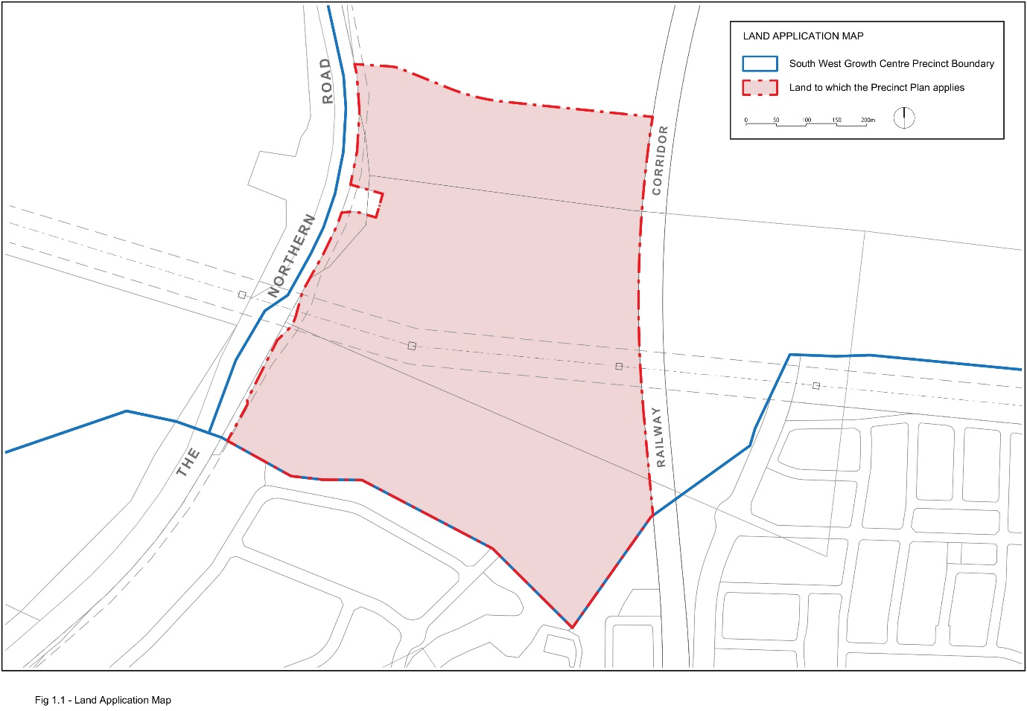
Figure 1-1: Land Application Map

Subdivision Planning and Design

2.1 Pondicherry (Part) Precinct Vision
The Pondicherry (Part) Precinct will deliver a high-quality urban environment following the principles of community pride, well-being, healthy living and educational excellence. The Part Precinct will incorporate a series of thoughtfully planned villages with high local amenity and quality connections to the job opportunities, community and recreational facilities afforded within the South West Growth Area. The Part Precinct will support increased tree canopy to create a greener and cooler neighbourhood. The Part Precinct will be an integral component of the local area linking to surrounding precincts including the established Oran Park and future precincts of Lowes Creek Marylands and South Creek West.
The urban framework of the Precinct will respond to the unique characteristics of the existing built and natural environment including:
- The retention of existing remnant vegetation and hollow bearing trees where possible;
- Creation of meaningful green-grid connections to local creek networks in Oran Park and the wider Western Parkland City;
- Establishing streets with increased tree canopy through wider verges;
- Delivery of attractive, high amenity residential streetscapes, open space and pedestrian/cycle connections that are responsive to site constraints; and
- Design of public spaces to incorporate Aboriginal cultural history.
The Part Precinct will include low-density residential development providing attractive streetscapes structured around well-connected walkable neighbourhoods and local open spaces providing intimate opportunities for community building and local resident interaction. The urban structure will be connected by a network of active pedestrian and cycle paths layered and intertwined with the blue-green grid offered through the local creek corridors, linking to the wider network to form the Western Parkland City.
The future North-South Rail corridor forms part of the planning and design for the Precinct, with vehicular and pedestrian crossing points integrated with the local neighbourhoods.

2.2 Pondicherry (Part) Precinct Supporting Specialist Studies
The following supporting specialist studies have informed the Pondicherry (Part) Precinct Indicative Layout Plan and planning controls:
- Tranche 41 Tree Strategy (August 2021) – JMD design;
- Social Infrastructure Assessment (September 2020) – Elton Consulting;
- Tranche 41 Aboriginal Cultural Heritage Assessment (December 2020) – Kelleher Nightingale Consulting;
- Pondicherry Aboriginal Heritage Assessment (August 2021) – Kelleher Nightingale Consulting;
- Traffic and Access Assessment Report (April 2020) – Positive Traffic;
- Geotechnical Investigation Summary Letter (January 2020) – Douglas Partners;
- Salinity Summary Letter (January 2020) – Douglas Partners;
- Contamination Summary Letter (January 2020) – Douglas Partners;
- Terrestrial Ecological Analysis (September 2020) – Eco Logical Australia;
- Riparian Assessment (January 2021) – Eco Logical Australia;
- Bushfire Constraints and Opportunities Assessment (September 2020) – Eco Logical Australia;
- Infrastructure Servicing Report (February 2020) – Calibre Consulting;
- Reverse Amenity Air Quality Assessment (September 2020) – Astute Environmental Consulting;
- Noise and Vibration Assessment (January 2021) – WSP; and
- Stormwater Management Report (September 2020) – Calibre Consulting.

2.3 Referenced Figures
Note: The figures included in this section are those referenced in Part 2 Precinct Planning Outcomes, and Part 3 Neighbourhood and Subdivision Design, of the DCP as indicated in Table 2-1.
Table 2-1: Referenced Figures
Referenced figure | Section in main body of the DCP
Figure 2-1: Indicative Layout Plan | 2.2 The Indicative Layout Plan
Figure 2-2: Flood prone land | 2.3.1 Flooding
Figure 2-3: Key elements of the water cycle management and ecology strategy | 2.3.2 Water Cycle Management  2.3.5. Native Vegetation and Ecology  3.2.3 Street Network and Design
Figure 2-4: Areas of potential salinity risk | 2.3.3 Salinity and Soil Management
Figure 2-5: Indigenous cultural heritage | 2.3.4 Aboriginal and European heritage
Figure 2-6: Bushfire risk and Asset Protection Zone requirements | 2.3.6 Bushfire hazard management
Figure 2-7: Potential contamination risk | 2.3.7 Site Contamination
Figure 2-8: Location of easements | 2.3.8 Development on and adjacent to electricity easements
Figure 2-9: Noise impact areas | 2.3.9 Noise
Figure 2-10: Residential structure | 3.1.1 Residential Density
Figure 2-11: Precinct road hierarchy | 3.3.1 Layout and Design  3.3.6 Access to arterial roads, sub-arterial road and transit boulevards
Figure 2-12: Pedestrian and cycle network | 3.3.4 Pedestrian and Cycle Network
Figure 2-13: Public transport network | 3.3 Movement Network
Figure 2-14: Open space network | 3.1.2 Block and Lot Layout
Figure 3-1: Transgrid Electricity Easement (Public Ownership) | 2.3.8 Development of or Adjacent to Electricity and gas Easements
Figure 3-2: Transgrid Electricity Easement (Private Ownership) | 2.3.8 Development of or Adjacent to Electricity and gas Easements
Figure 3-3: Local Street Cross Section (Typical) | 3.3 Movement Network
Figure 3-4: Local Street Cross Section (Flex Zone) | 3.3 Movement Network
Figure 3-5: Green Link Cross Section (Typical) | 3.3 Movement Network
Figure 3-6: Green Link Cross Section (Flex Zone) | 3.3 Movement Network
Figure 3-7: Collector Road Cross Section – No Median (Typical) | 3.3 Movement Network
Figure 3-8: Collector Road Cross Section – No Median (Flex Zone) | 3.3 Movement Network
Figure 3-9: Collector Road Cross Section – Median (Typical) | 3.3 Movement Network
Figure 3-10: Collector Road Cross Section – Median (Flex Zone) | 3.3 Movement Network
Figure 3-11: Sub-Arterial Road Cross Section (On Road Cycle Lane) | 3.3 Movement Network
Figure 3-12: Typical Flex Zone Design | 3.3 Movement Network

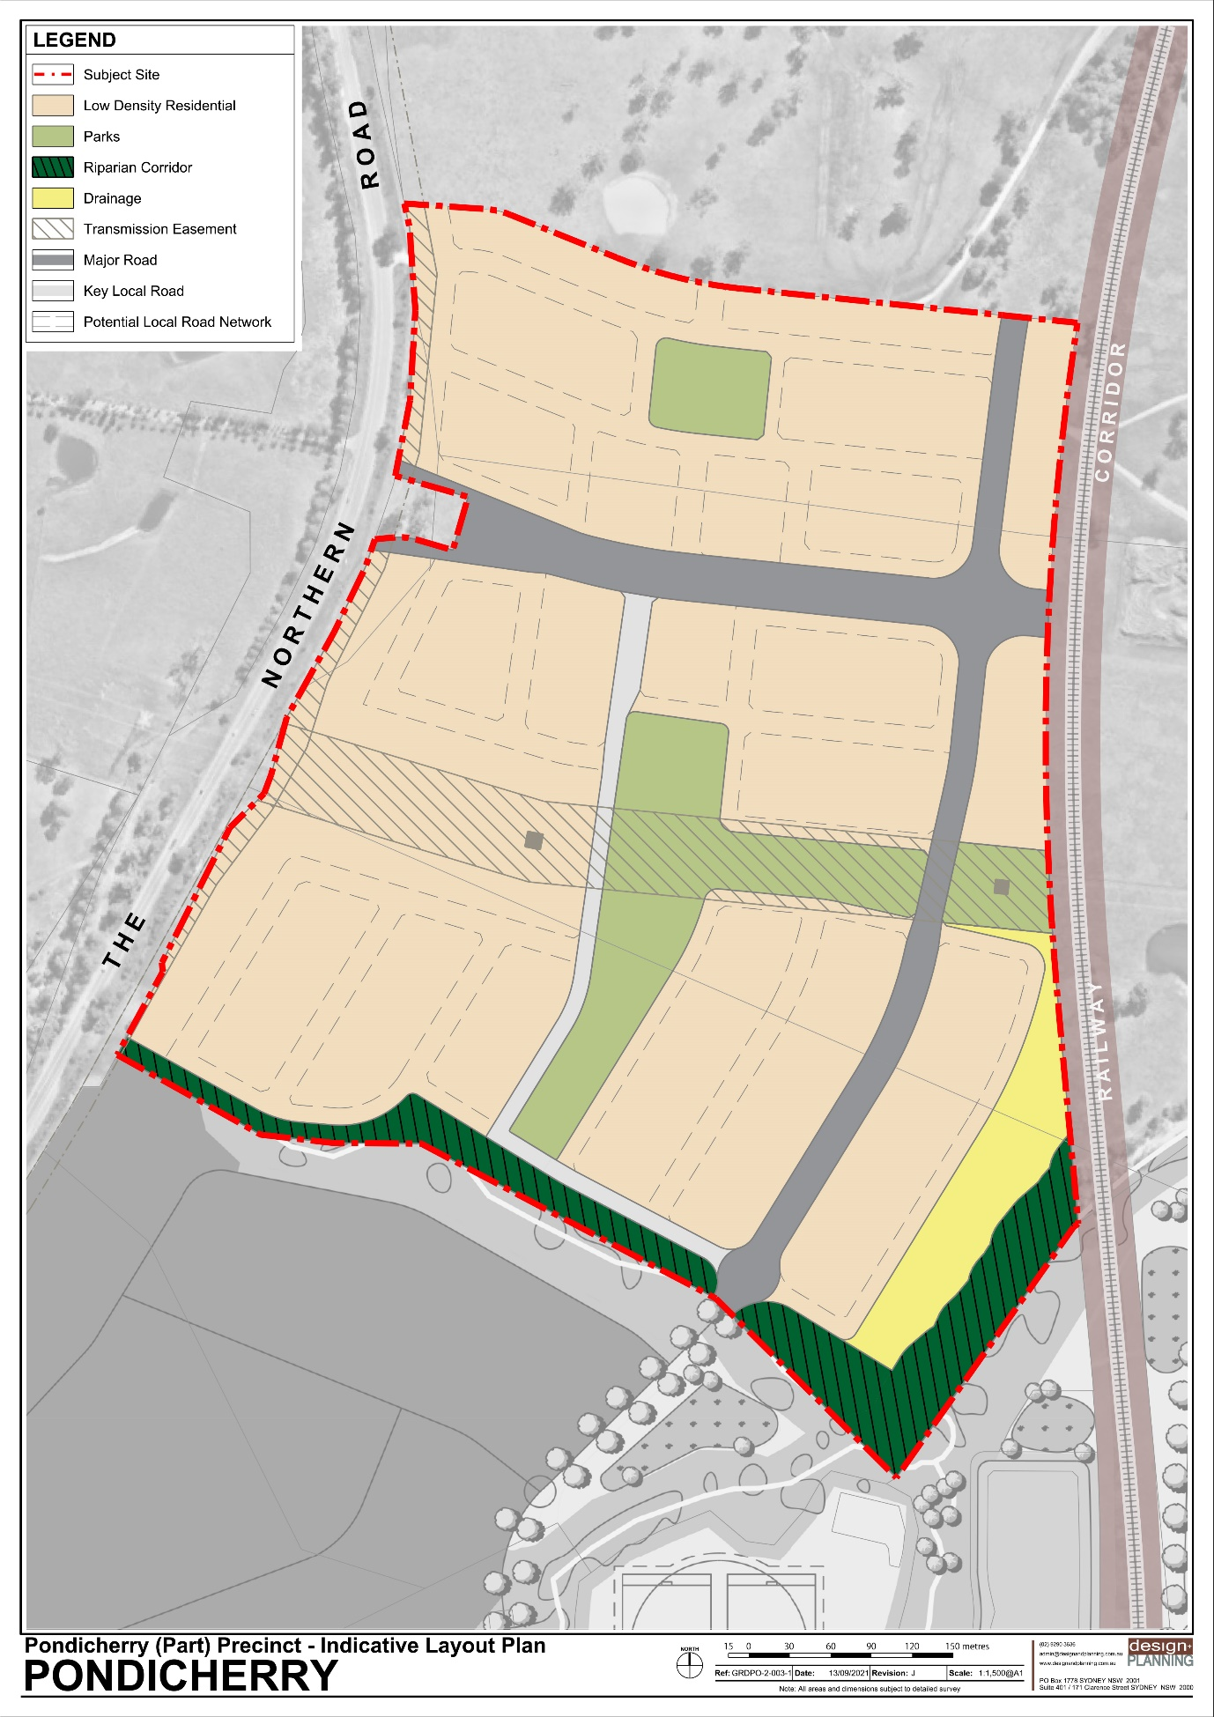
Figure 2-1: Indicative Layout Plan

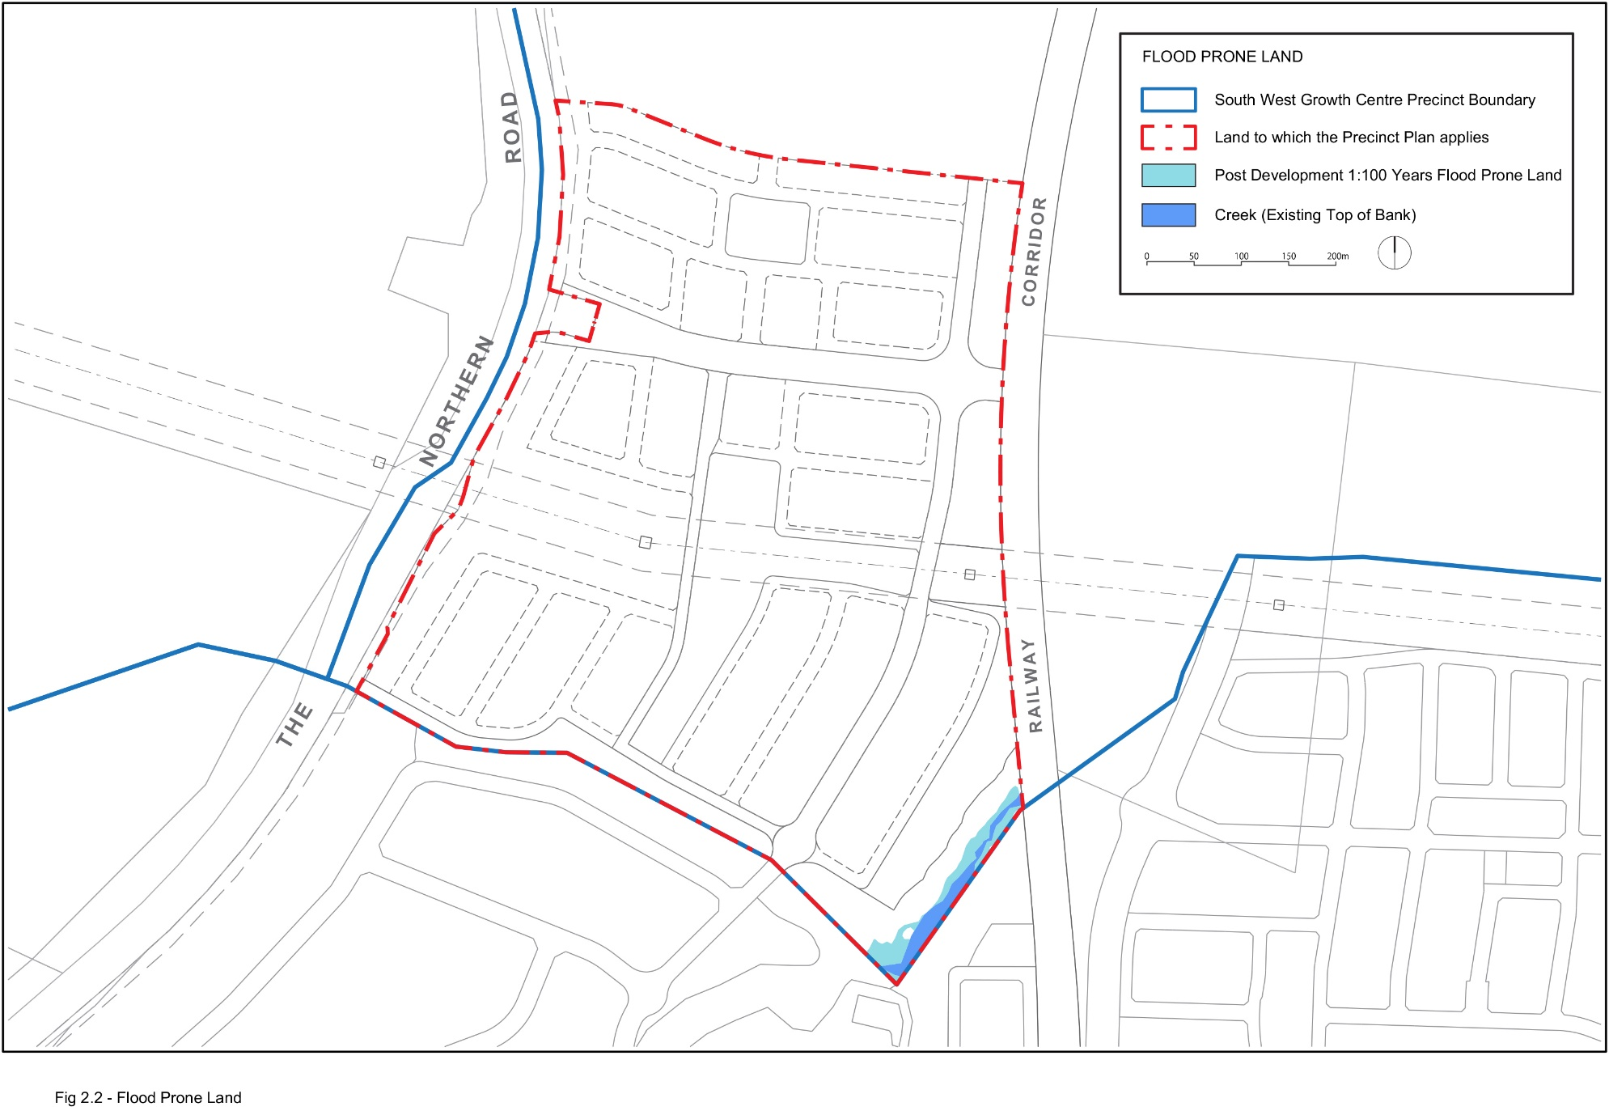
Figure 2-2: Flood Prone Land
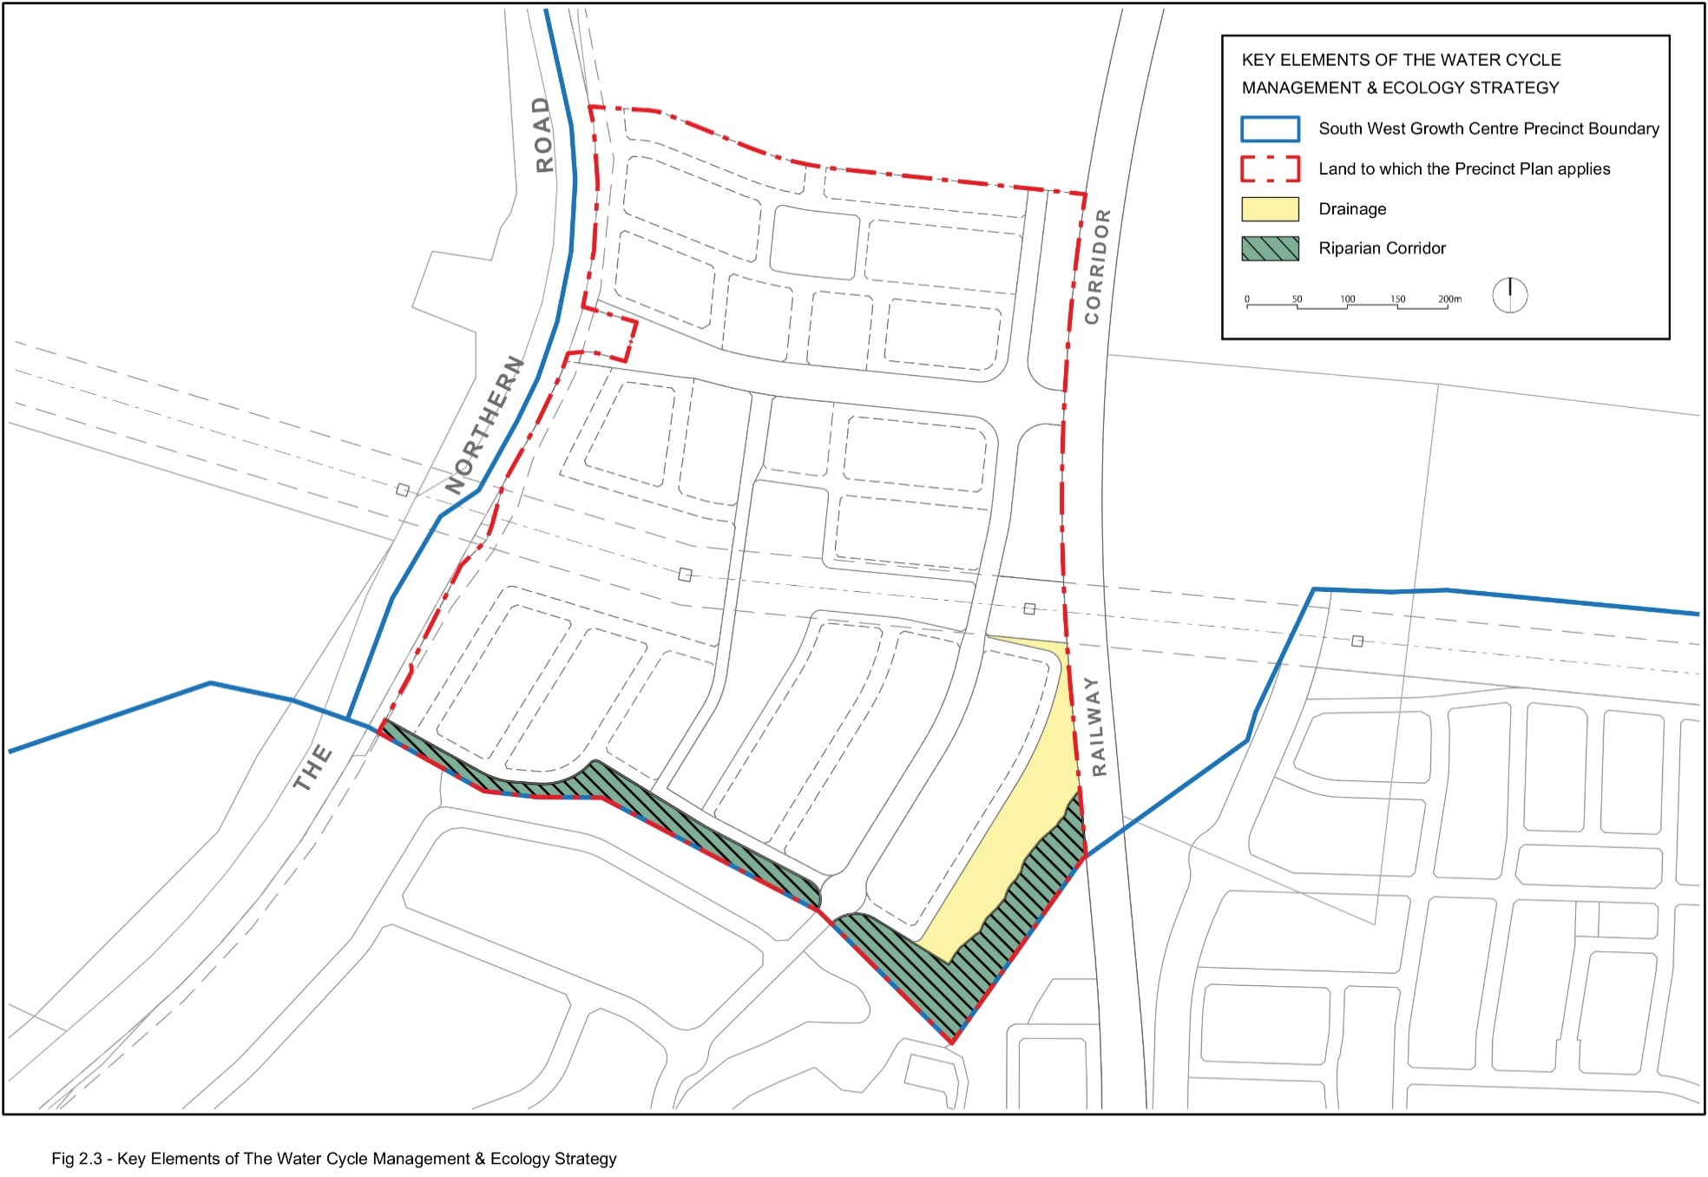
Figure 2-3: Key Elements of the Water Cycle Management and Ecology Strategy
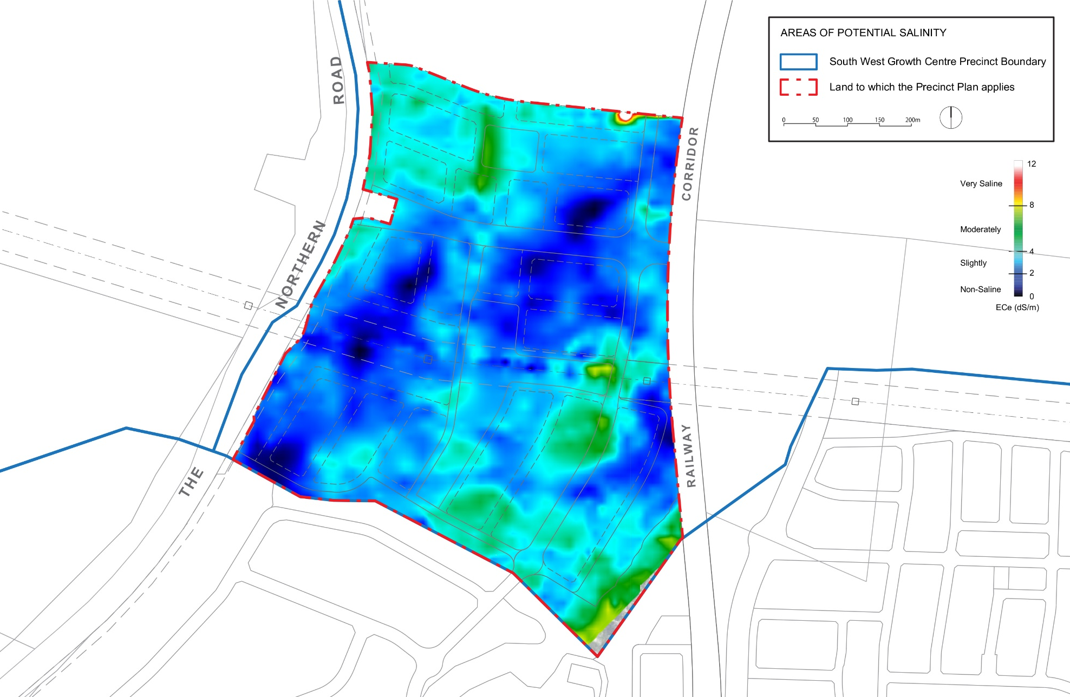
Figure 2-4: Areas of Potential Salinity
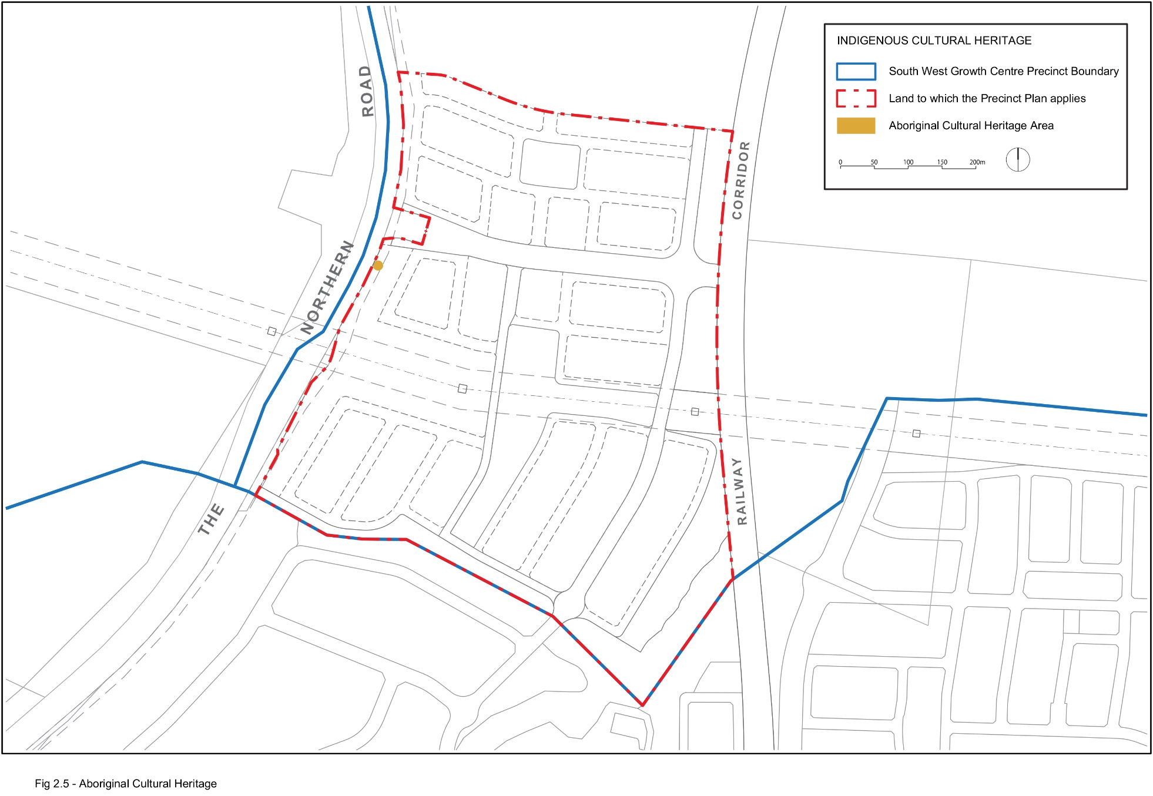
Figure 2-5: Aboriginal Cultural Heritage
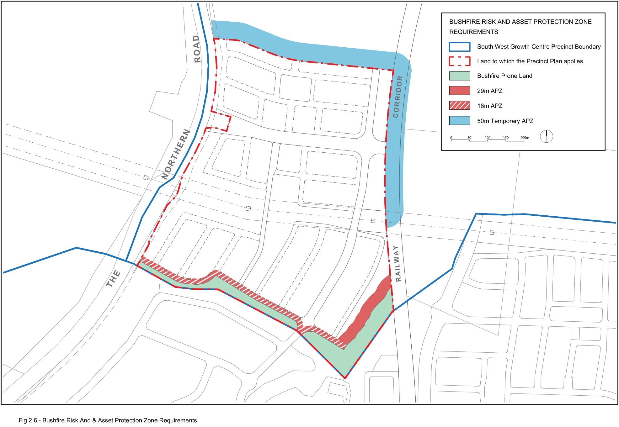
Figure 2-6: Bushfire Risk and Asset Protection Zone Requirements
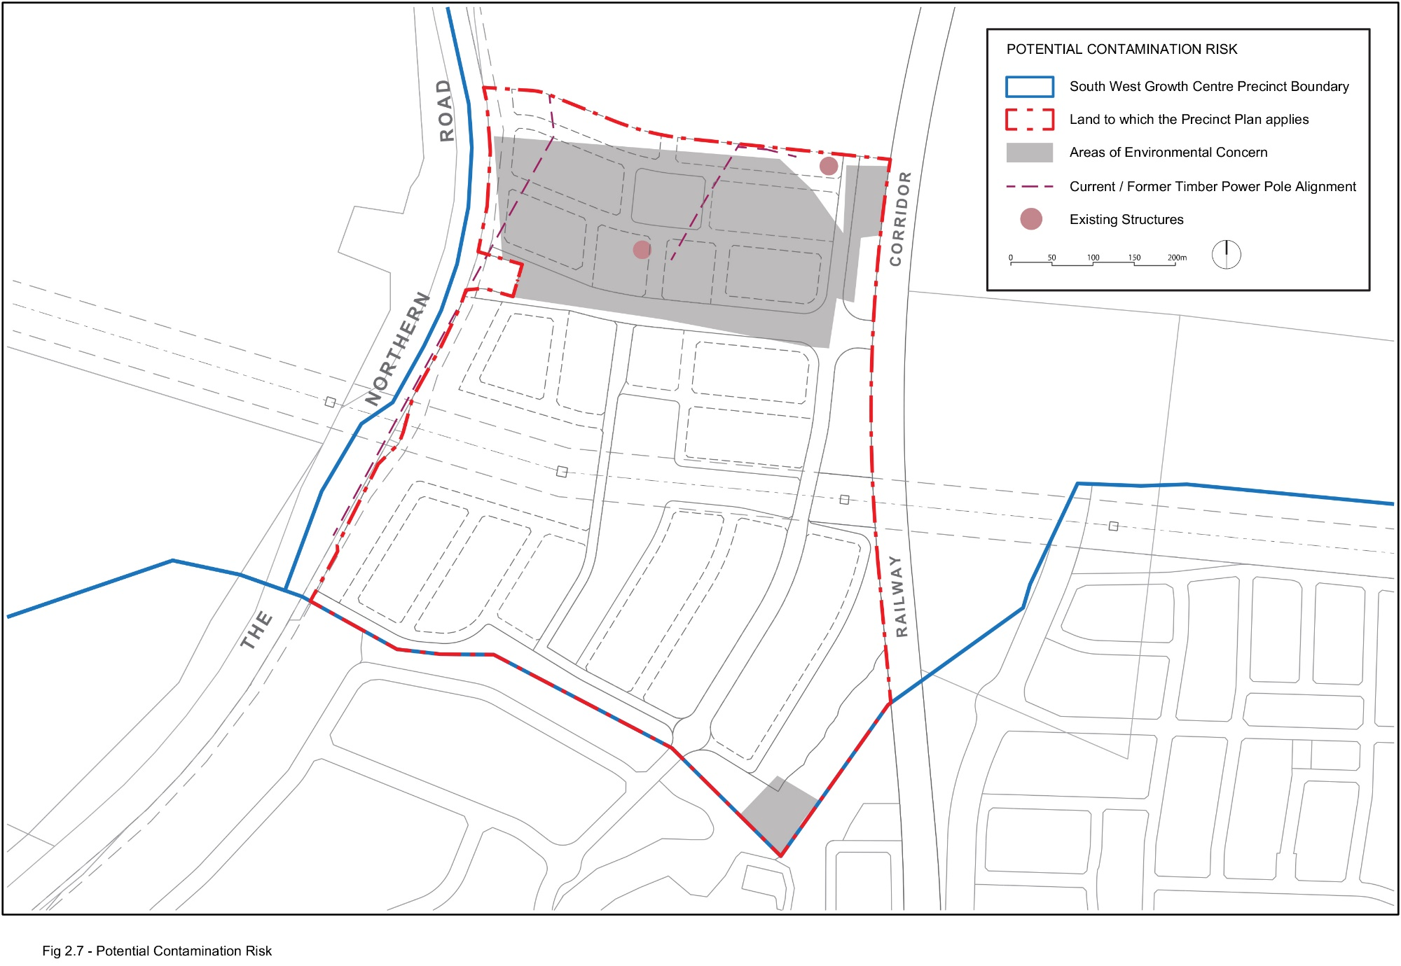
Figure 2-7: Potential Contamination Risk
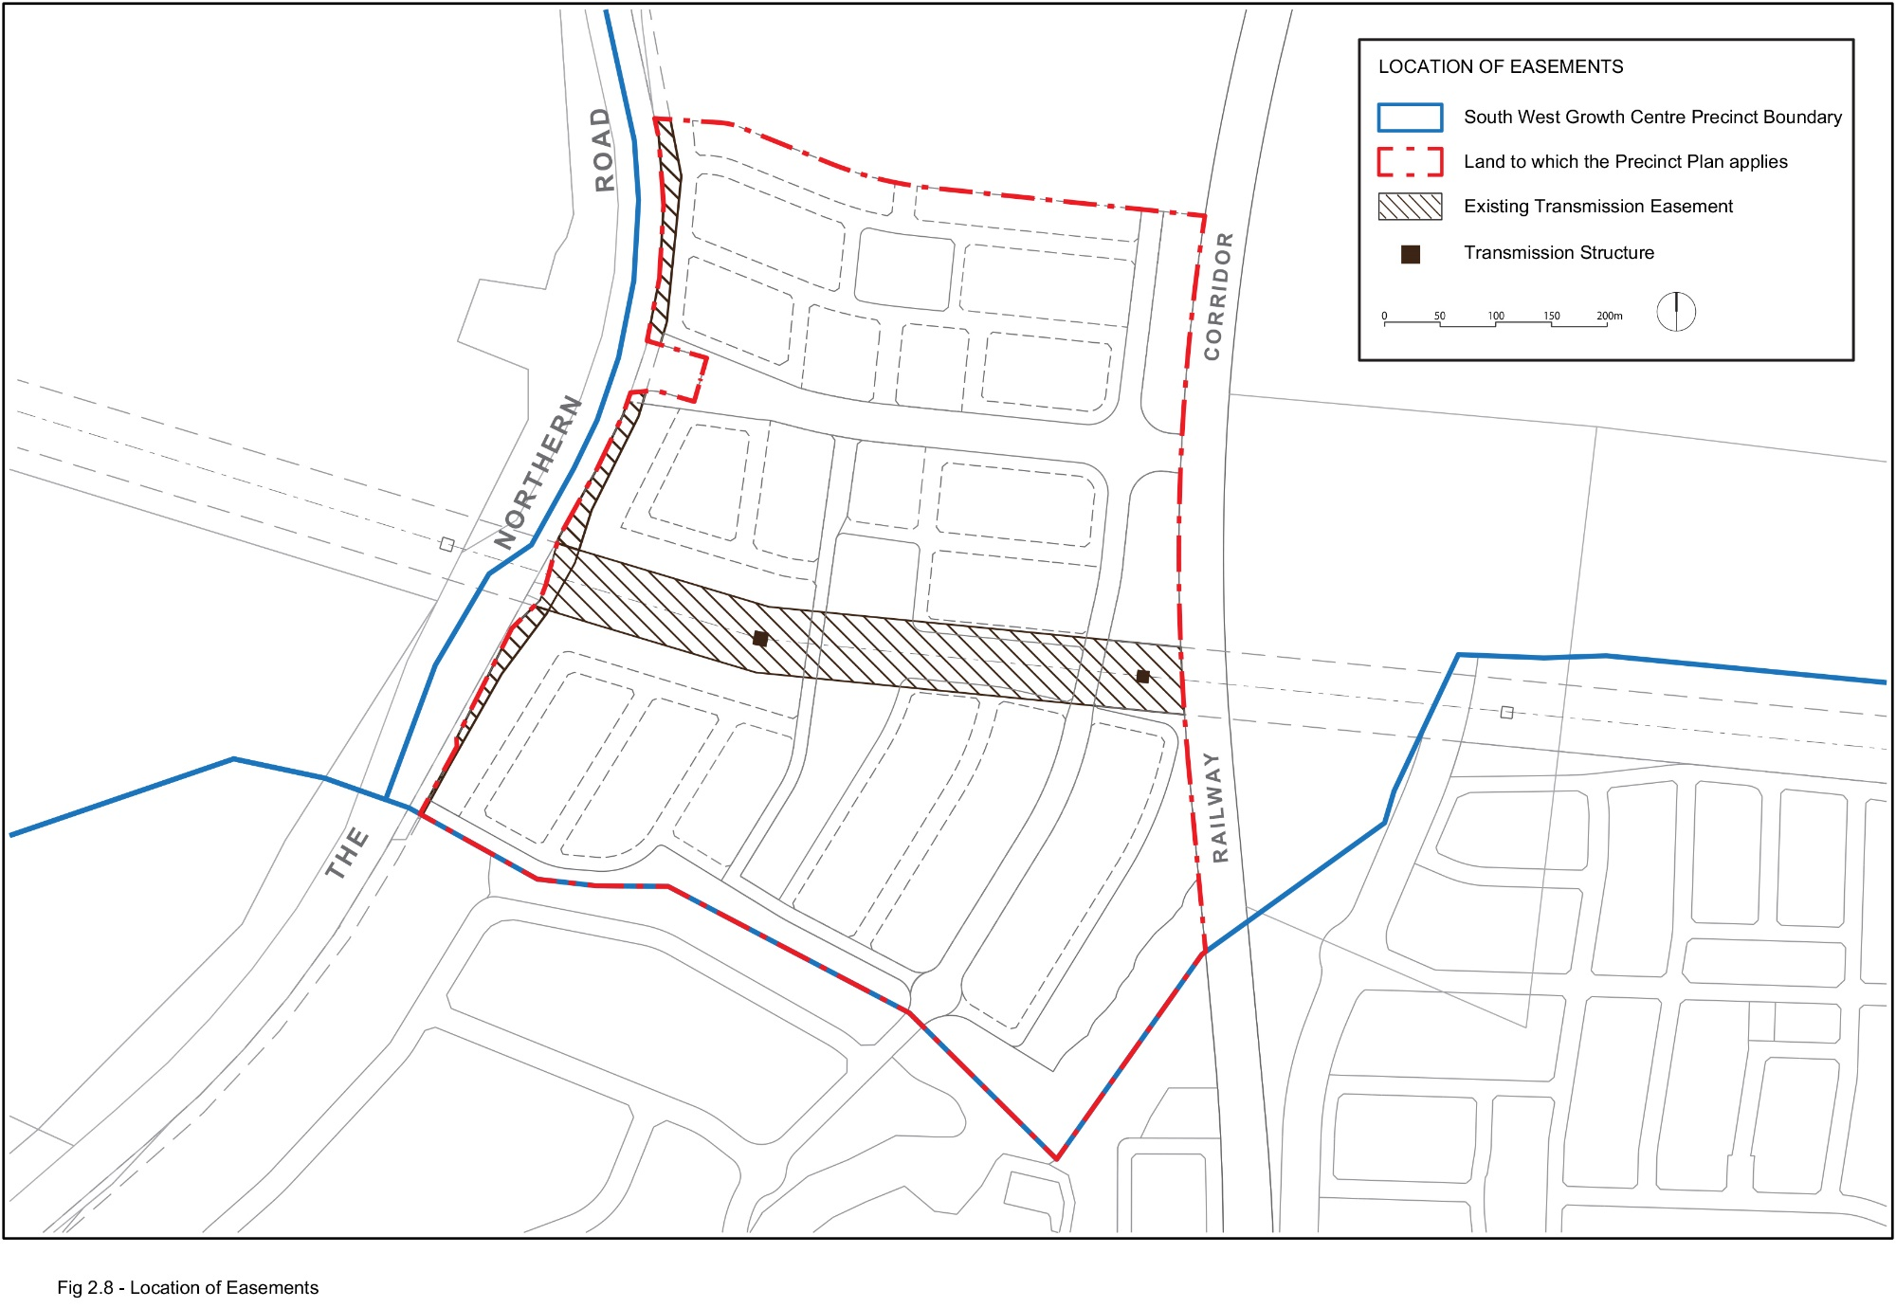
Figure 2-8: Location of Easements
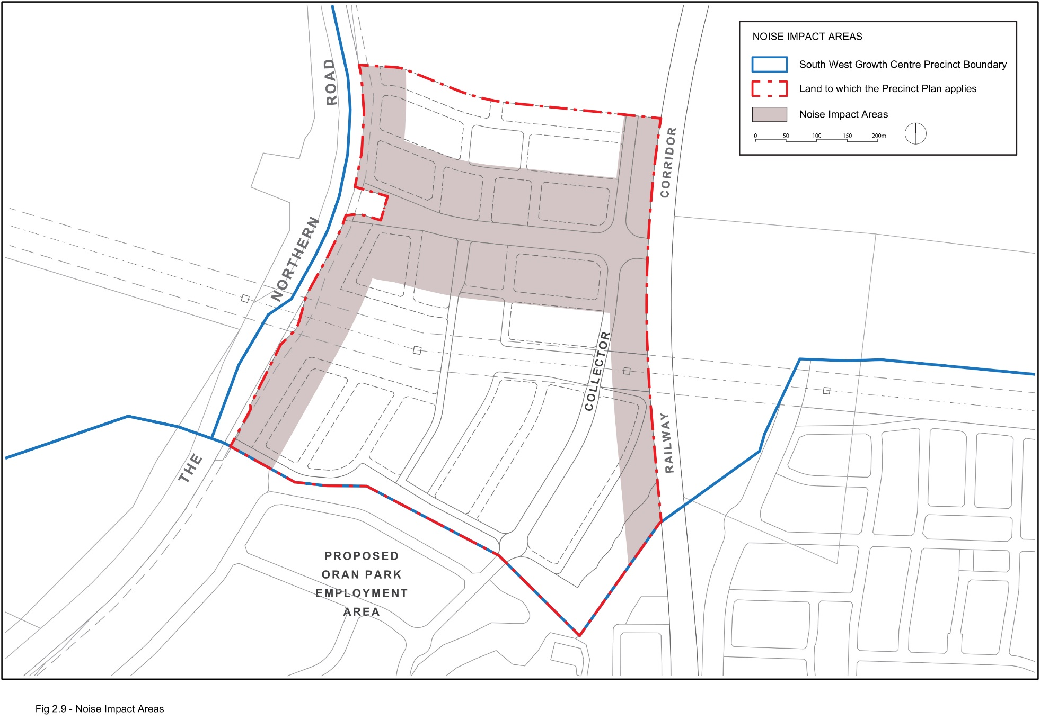
Figure 2-9: Noise Impact Areas
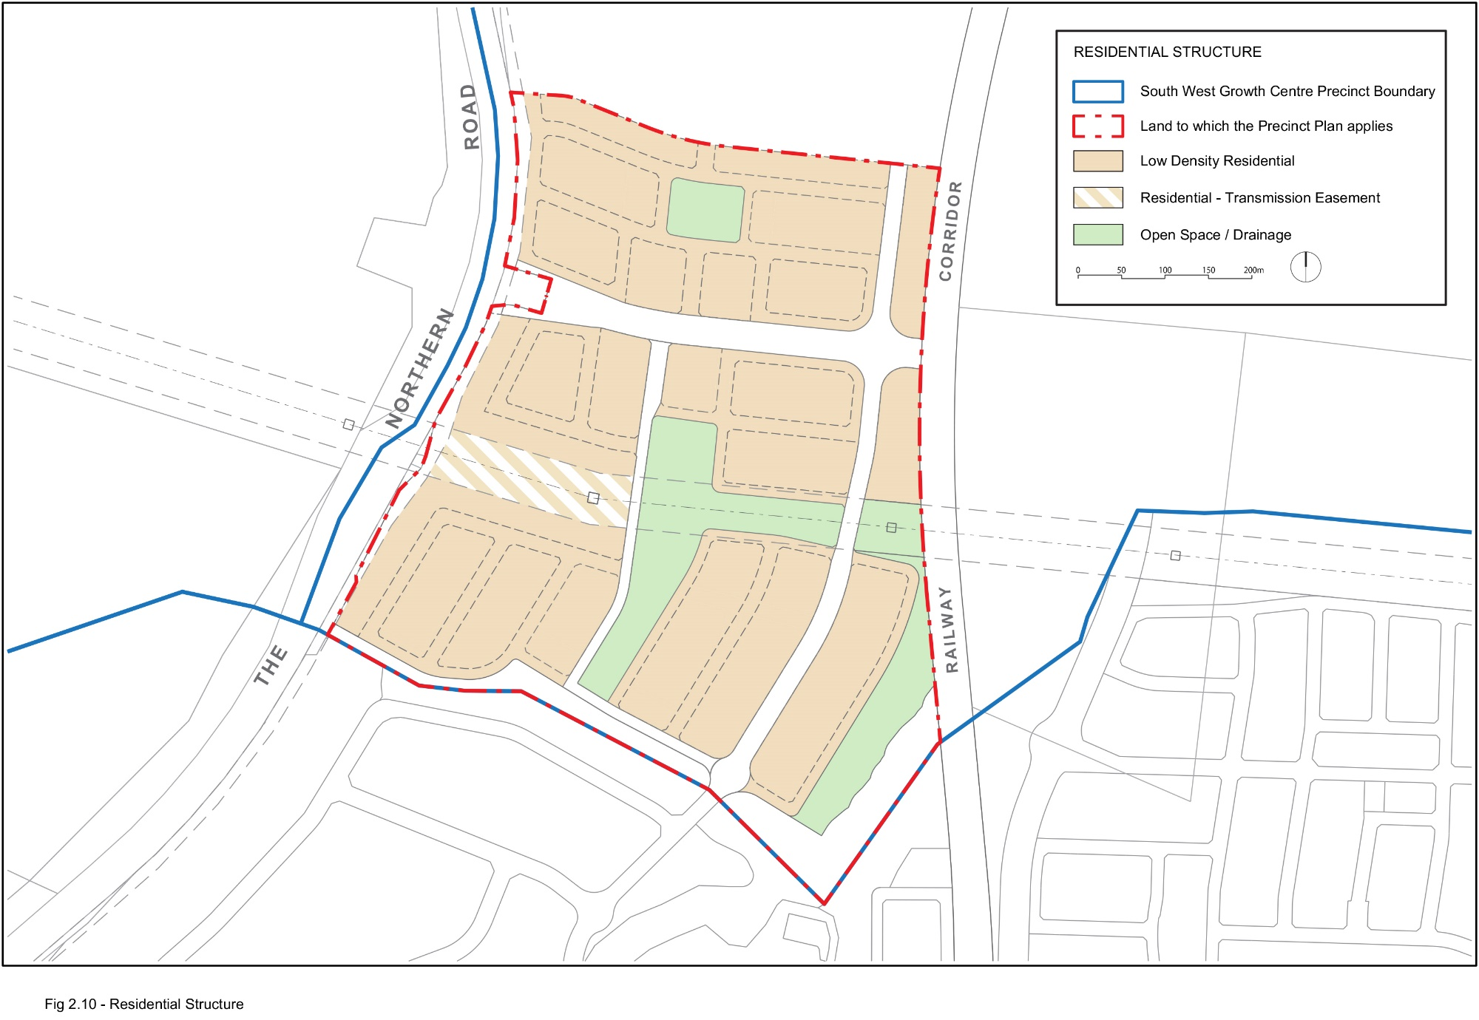
Figure 2-10: Residential Structure
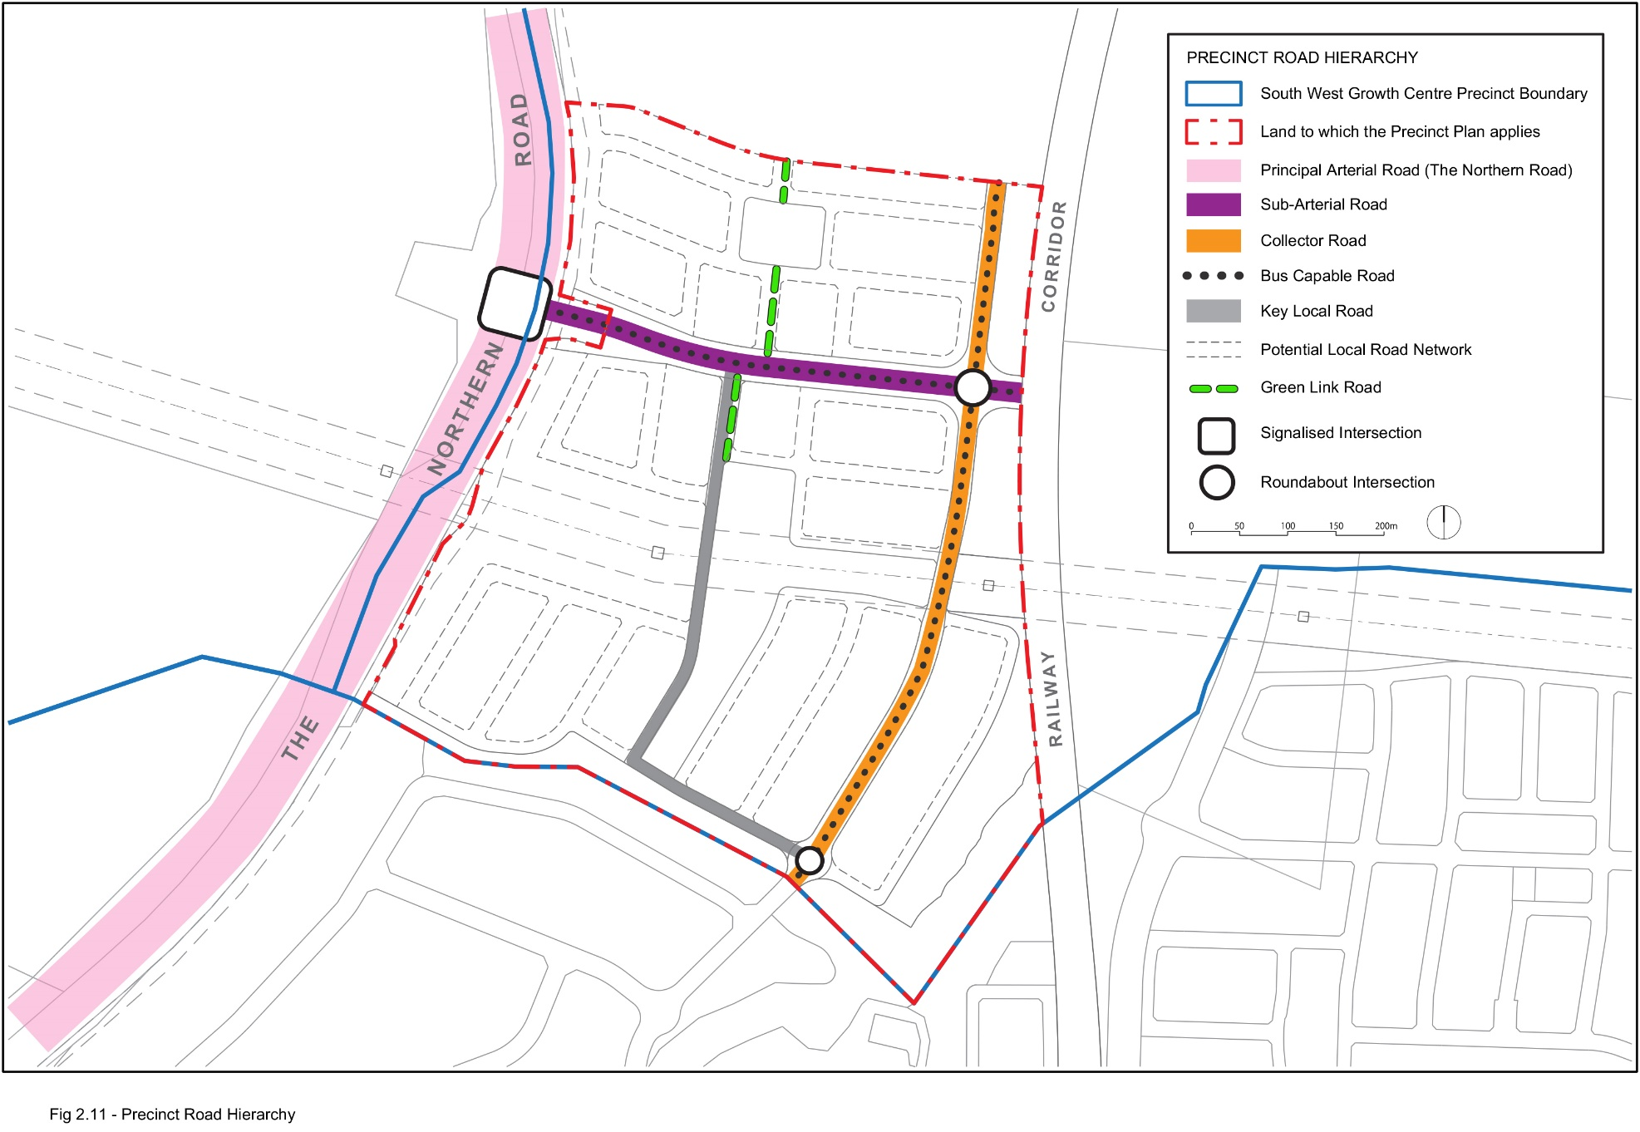
Figure 2-11: Precinct Road Hierarchy
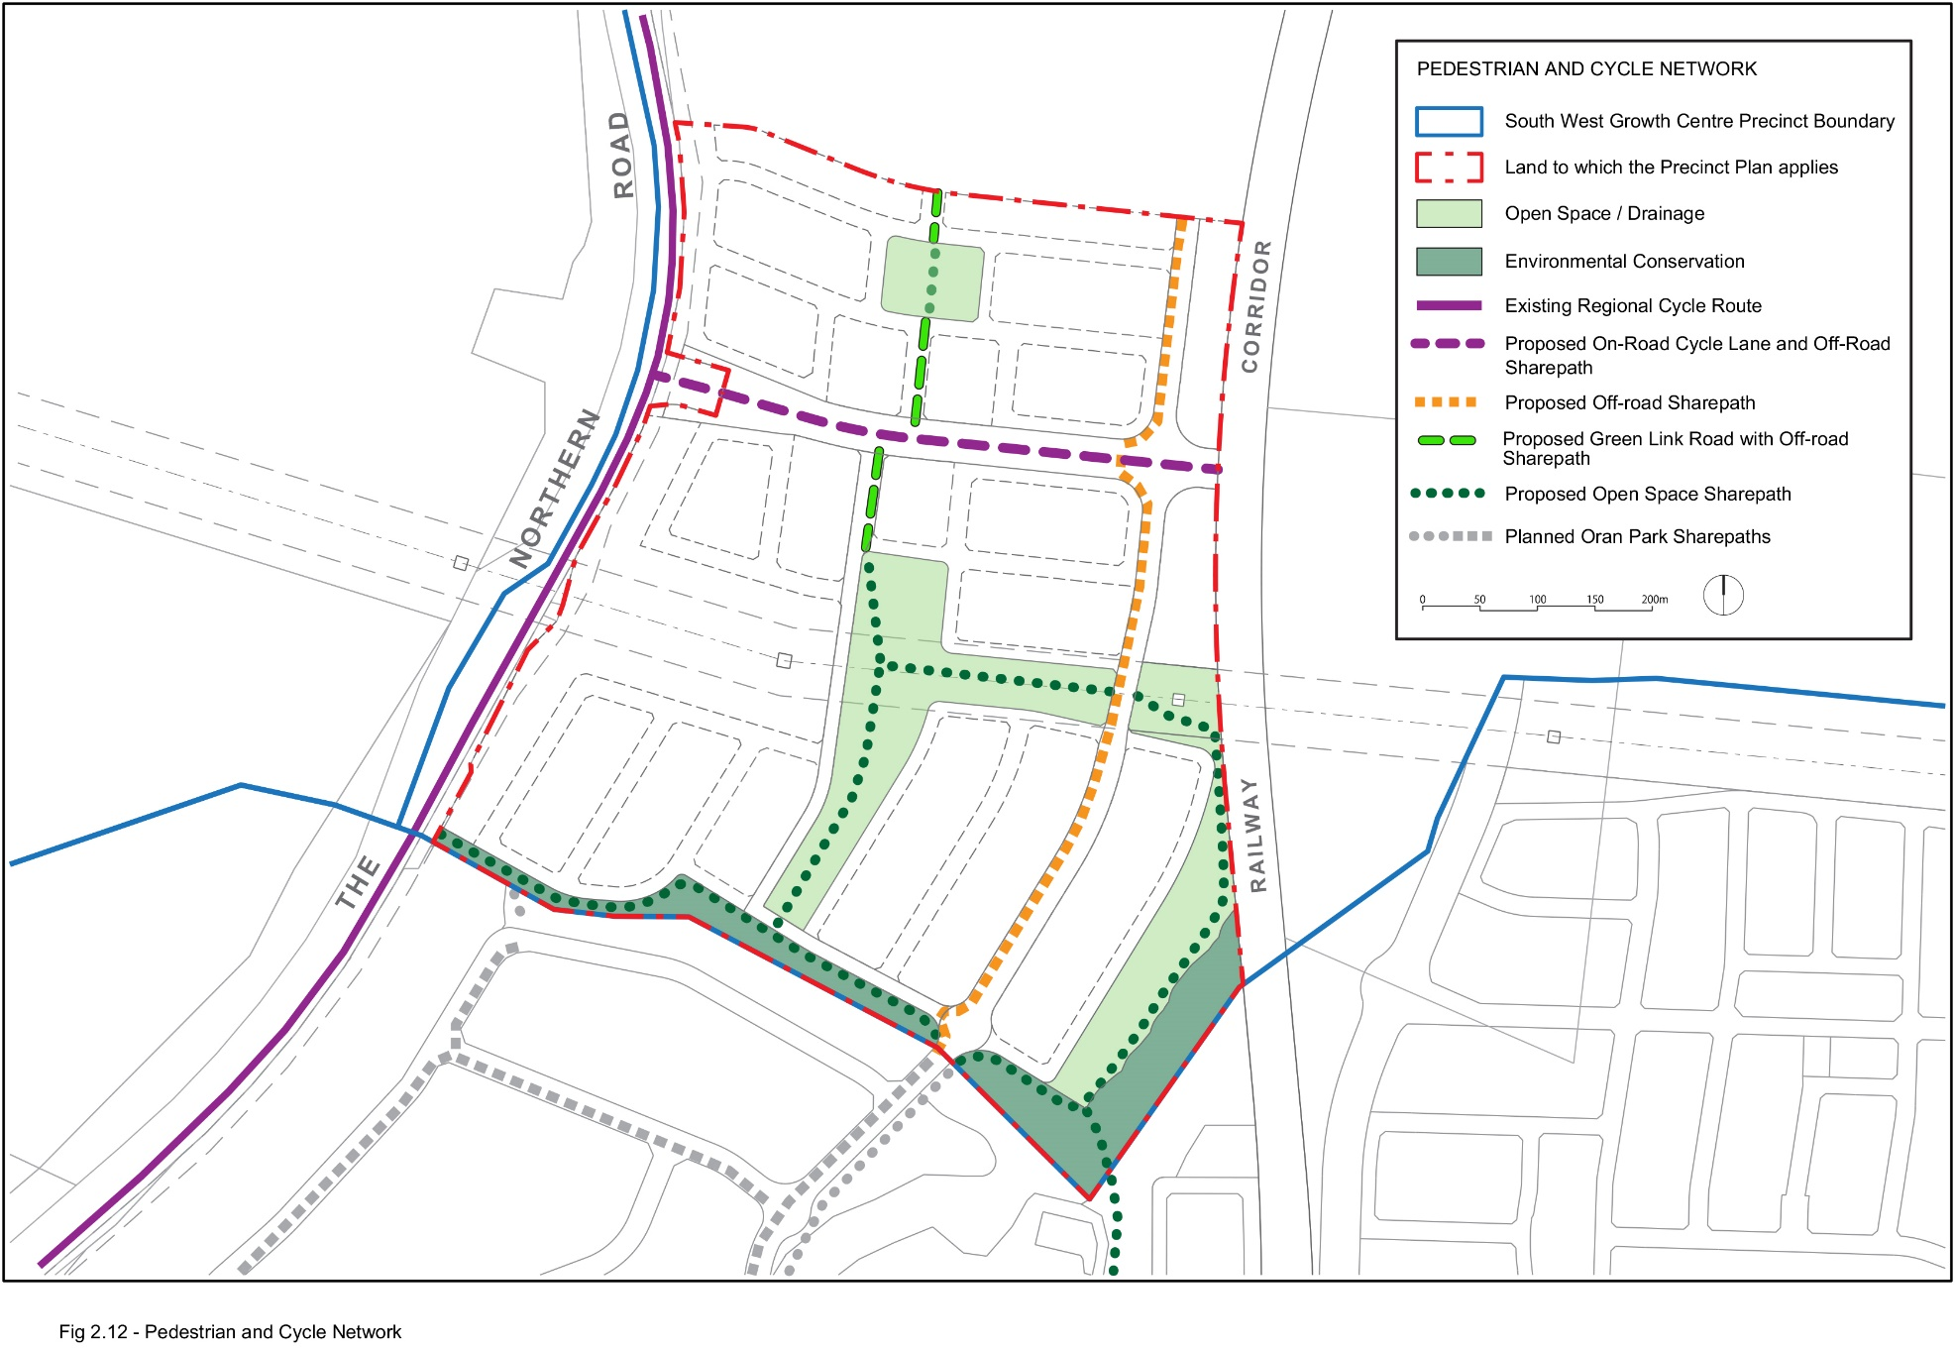
Figure 2-12: Pedestrian and Cycle Network
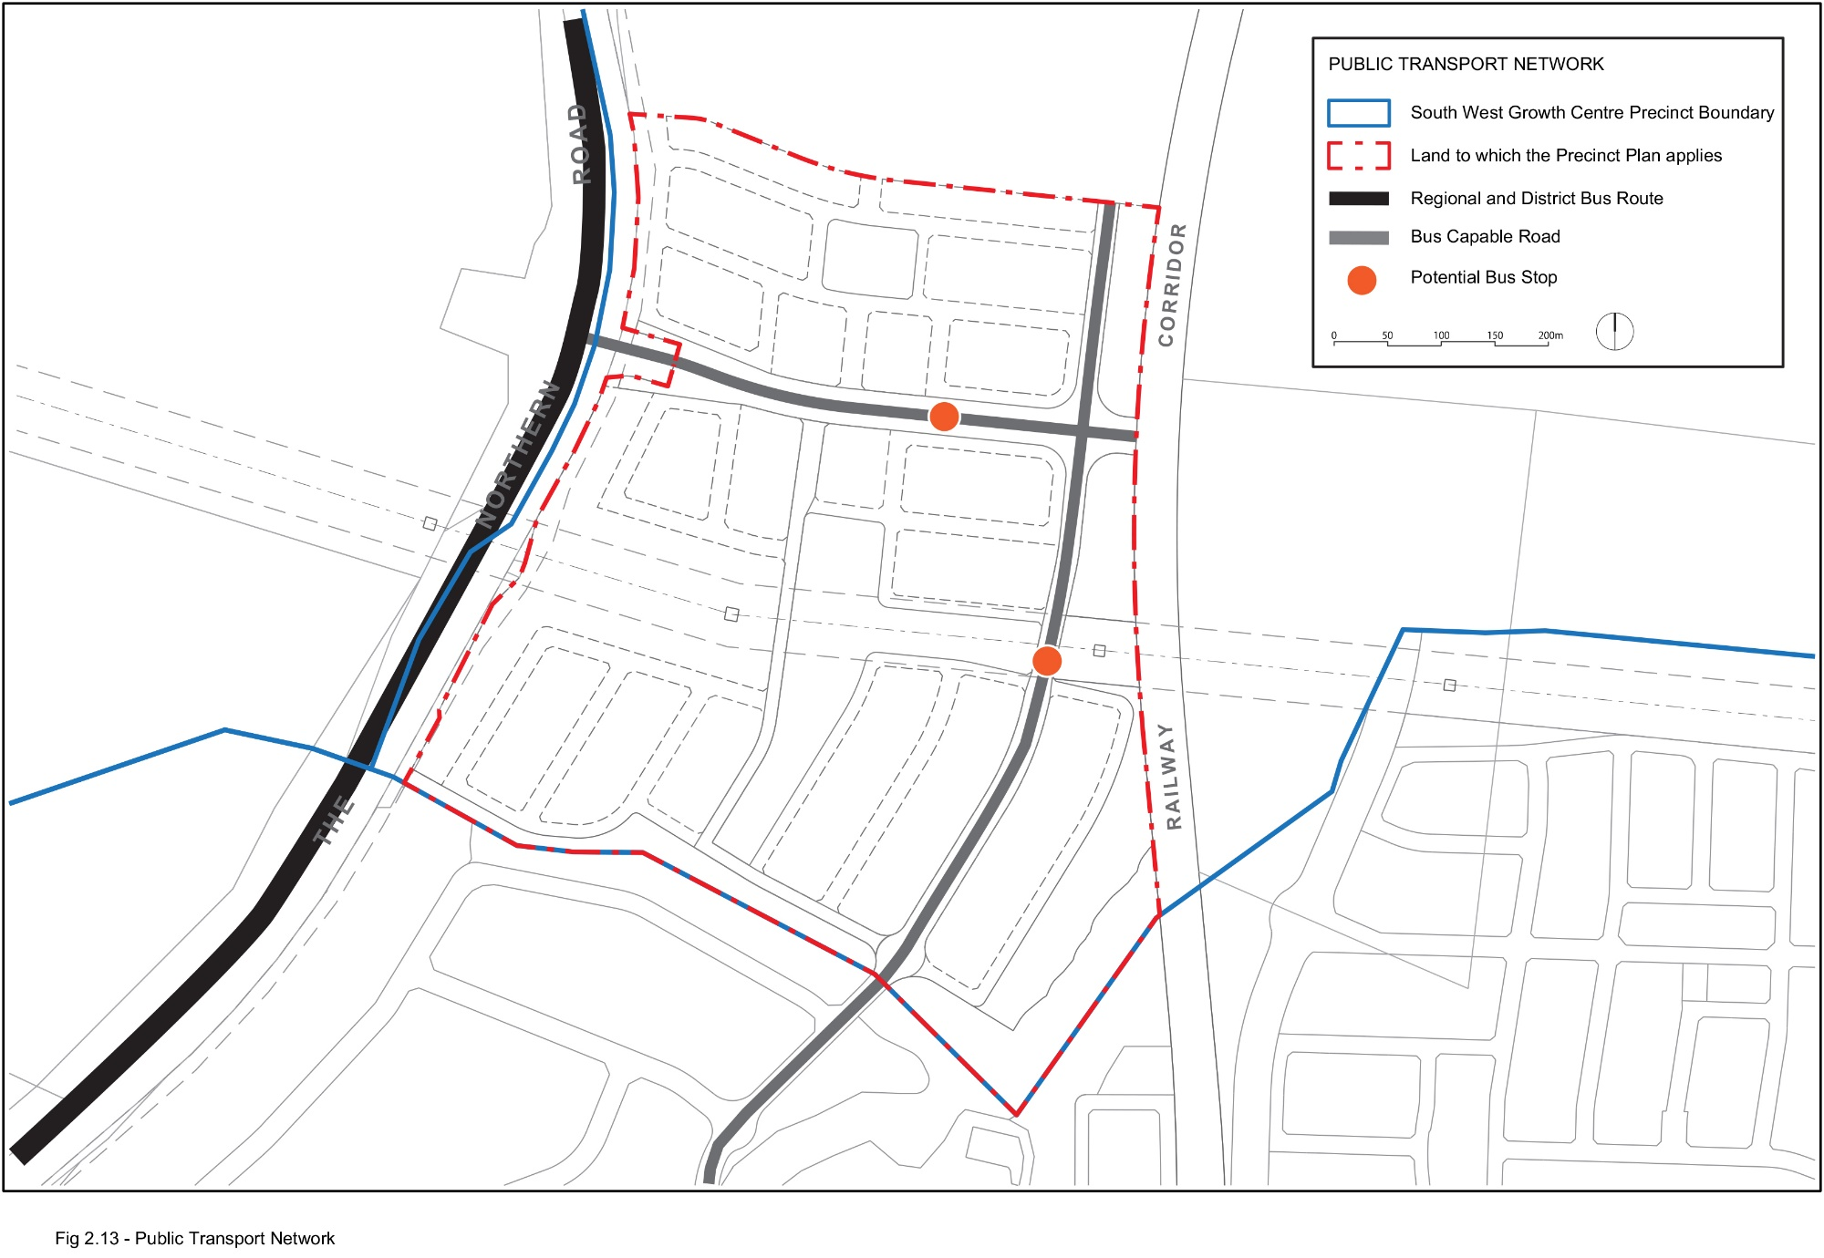
Figure 2-13: Public Transport Network

2.4 Public Transport
Objectives
- Encourage the use of public transport through the provision of integrated bus, pedestrian and cycle routes within the Precinct.
Controls
- The design of roads with Bus Routes and Bus Capable Roads in Figure 2-13 within the Precinct is to accommodate bus movements.
- Bus stops are to be provided on-street and not within indented bays. Bus shelters are to be provided at key stops and installed at the subdivision construction stage.
- Applications for subdivision and development shall demonstrate how bus routes and bus movements are to be accommodated within the Precinct for each stage of development.

2.5 Open Space and Recreation Network
Objectives
- To provide open space to local residents for social interaction and passive recreation activities.
- To establish a sense of place and orientation within the neighbourhood by locating open space to take advantage of significant or prominent landscape features, such as views, riparian corridors, high points and areas of natural and cultural heritage significance.
- To provide equitable distribution of public open space and recreation opportunities.
- To ensure high quality design and embellishment of all public open space.
- To encourage the use of the major creek corridors for passive recreation purposes consistent with environmental objectives.
Controls
- Neighbourhood parks, open space contained within an electricity easement and environmental conservation and riparian corridors are to be provided generally in accordance with Figure 2-14 and Table 2-2.
- Neighbourhood parks are to be consistent with Council’s Spaces and Places Strategy, including neighbourhood open space between 0.5 – 1.5 hectares in area.. The following principles are to be taken into consideration in the location of neighbourhood parks:
    - where possible, parks are to be located in accordance with the Indicative Layout Plan (refer to Figure 2-1);
    - parks are to be located as focal points within residential neighbourhoods. All dwellings should be located no further than 400m from a neighbourhood park;
    - parks shall be highly accessible and linked by pedestrian and/or cycle routes;
    - parks shall be located and designed to accommodate remnant vegetation and should be linked to and integrated with riparian corridors; and
    - parks shall be generally bordered by streets on all sides with houses oriented towards them for surveillance.
- Where riparian corridors are proposed to be in public ownership, detailed design must provide opportunities for pedestrian paths and cycleways, fitness trails and additional open space in a manner that maintains the environmental significance of these areas while promoting multi-purpose community spaces.
- A Public Domain and Landscape Plan is to be submitted for each neighbourhood park and other passive open space areas at the time of subdivision of the adjoining residential area, consistent with the Tranche 41 Tree Strategy (August 2021) – JMD design . The selection of landscape species for public open space areas is to consider bush fire risk. The Plan is to provide details on these elements:

- earthworks;
- street furniture;
- plant species and sizes;
- play equipment;
- utilities and services;
- public art;
- hard and soft landscaping treatments;
- signage and lighting;
- any entry statements;
- waste facilities; and
- interpretative material.
Table 2-2: Summary of Open Space and Recreation Requirements
Open Space Type | Minimum size | Facilities
T41-LP1 – Neighbourhood Park | 10,300m² | Facilities to be provided on each area of open space will be determined and designed according to the processes outlined in the Tranche 41 Voluntary Planning Agreement.
T41-LP2 – Neighbourhood Park | 5,400m²
T41-LP3 – Neighbourhood Park | 5,500m²
T41-E1 – Neighbourhood Park (Transmission Easement) | 11,500m²
T41-E2 – Neighbourhood Park (Transmission Easement) | 4,400m²

Note: Where development includes land within or is in proximity to a Riparian Protection Area, refer to the Guidelines for riparian corridors on waterfront land prepared by the NSW Office of Water. The Guidelines contain the outcomes and requirements for development on land containing or in proximity to a riparian protection area within the Growth Centres. The guidelines are available at www.industry.nsw.gov.au.
Note: Controlled activities on waterfront land are regulated by the Water Management Act (2000) (WM ACT) administered by Natural Resources Access Regulator (NRAR). Waterfront land includes the bed and bank of any river, lake or estuary and all land within 40m of the higher bank of the river, lake or estuary. Applicants must obtain a controlled activity approval from NRAR before commencing the controlled activity.

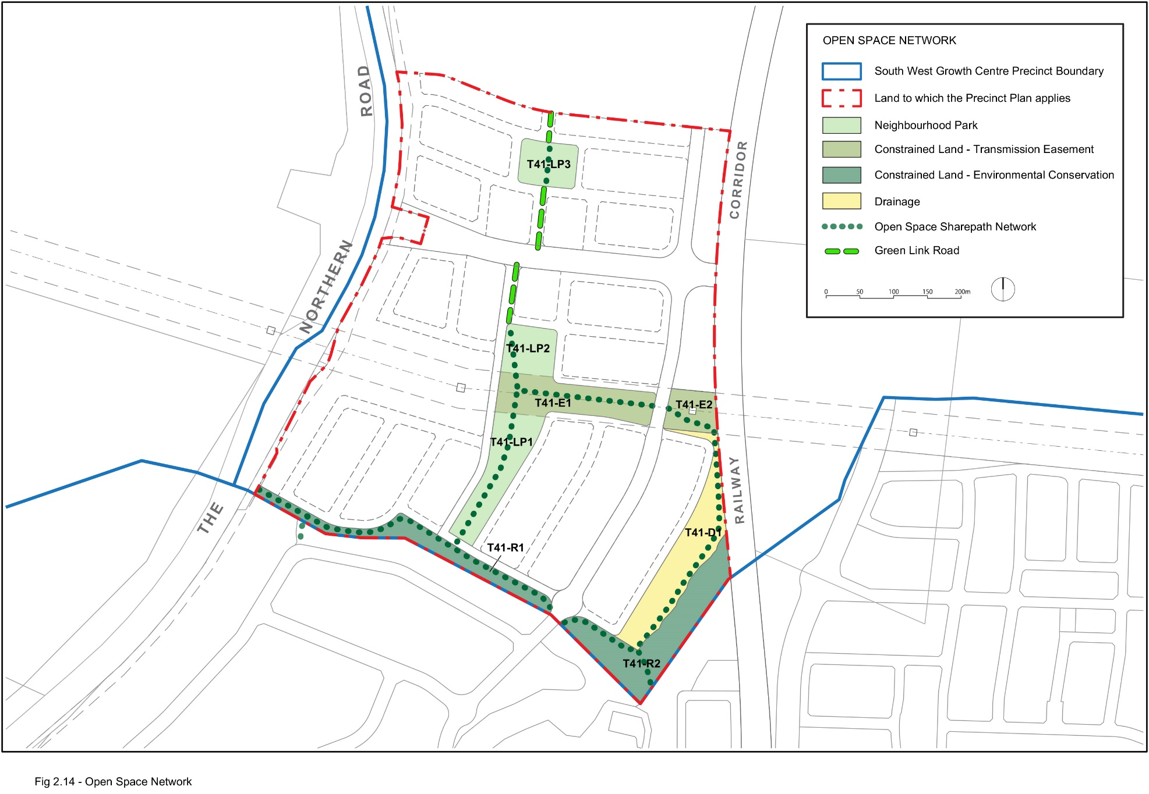
Figure 2-14: Open Space Network

2.6 Aboriginal Archaeology
Objectives
- To identify and manage Aboriginal heritage values to ensure enduring conservation outcomes.
- To provide opportunities for the appreciation of the areas of Aboriginal archaeology and cultural heritage.
Controls
- An Aboriginal Archaeology and Cultural Heritage Interpretation Plan must be submitted and approved by Council with the first development application, pertaining to the part precinct. The Plan must have consideration for the following:
- the meaning and significance of heritage places in ways that are enriching;
- the recommendations and findings in the archaeological report;
- evidence of consultation with local Aboriginal stakeholders;
- include ways to incorporate tangible, and cultural historical evidence of the place;
- ways to incorporate cultural and archaeological history in the design of public spaces included, but not limited to:
  - the design of noise mitigation measures along The Northern Road;
  - sculptures or other public art;
  - information plaques, panels and signage;
  - the naming of places or streets;
  - the design of road infrastructure or pavements;
  - the design of street or public domain furniture and landscaping; and
  - in the thematic design of residential areas such as the use of colour palettes or materials.
- Any development applications on land identified in Figure 2-5 must be accompanied by an Archaeological Assessment. The Assessment must be prepared by a suitably qualified archaeologist and is to include:
- an assessment of the archaeological potential of the place of Aboriginal significance;
- the likely impact of the development on the place of Aboriginal heritage significance;
- the compatibility of the development with the approved Aboriginal Archaeology and Cultural Heritage Interpretation Plan; and
- if relevant, a management strategy to conserve the significance of the place.
Note: Due to the sensitive nature of some heritage, particularly Aboriginal cultural heritage, interpretation may be inappropriate in some instances or may only be appropriate for particular aspects and not others. It is critical to strictly adhere to the wishes of Aboriginal stakeholders when developing interpretation projects.

Site Specific Development Controls

3.1 Development near or on Electricity Easements
Objectives
- To ensure that development on or near electricity easements does not impact on the integrity and safety of electricity infrastructure.
- To ensure reasonable standards of amenity for residential development within the vicinity of electricity easements.
- To encourage passive surveillance of electricity easements.
Controls
- Development within and adjacent electricity easements including but not limited to, landscaping and fencing, is to consider the appropriate and current Development Guidelines including:
  - Transgrid Easement Guidelines, Third Party Development;
  - Subdivision and Development Guidelines; and
  - Living and Working with electricity transmission lines.
  - Relevant Endeavour Energy specification
- Open space contained within an electricity easement and any road crossings of the easement should be in accordance with the Indicative Layout Plan (refer to Figure 2-1), Figure 2-14 and Table 2-2.
- Public roads within residential areas are encouraged adjacent to electricity easements to allow easy access to transmission towers and passive surveillance of open space (refer Figure 3-1).
- Where private ownership of the electricity easement is proposed, the number of private lots should be limited and contain a building footprint outside the easement (refer Figure 3-2).
- All proposed activities within electricity easements require approval from the relevant authority. Applicants should consult with electricity supply authorities prior to submitting a development application to Council. Evidence of approval is to be submitted with the development application.
- No buildings are permitted in electricity easements without the approval of the relevant electricity supply authority.

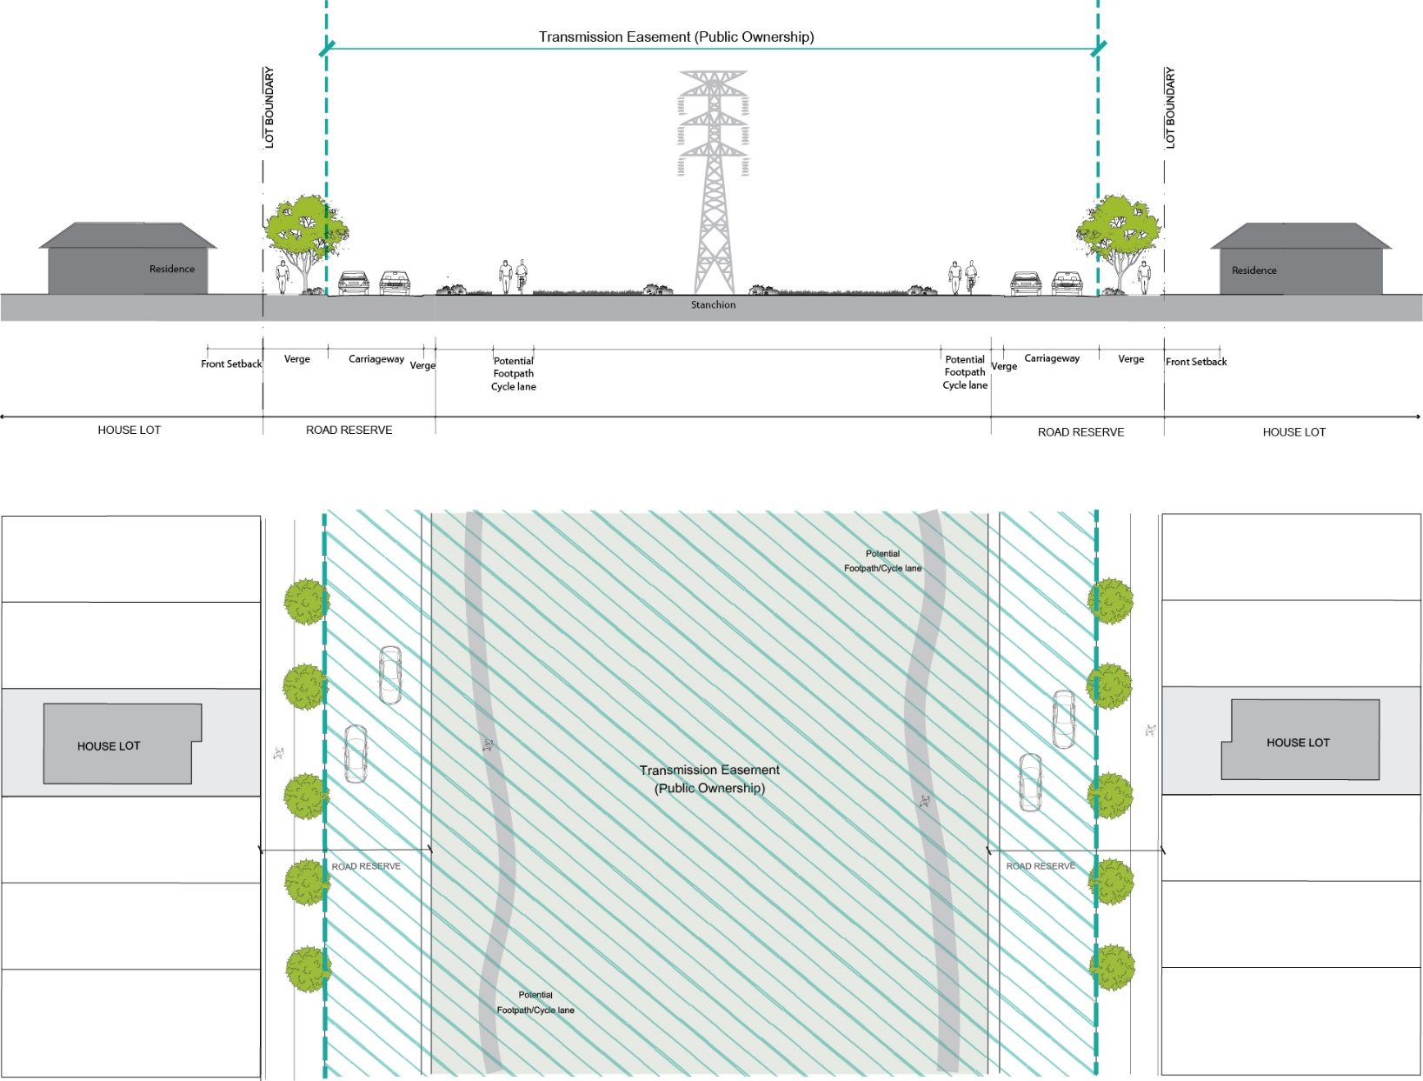
Figure 3-1: Transgrid Electricity Easement (Public Ownership)
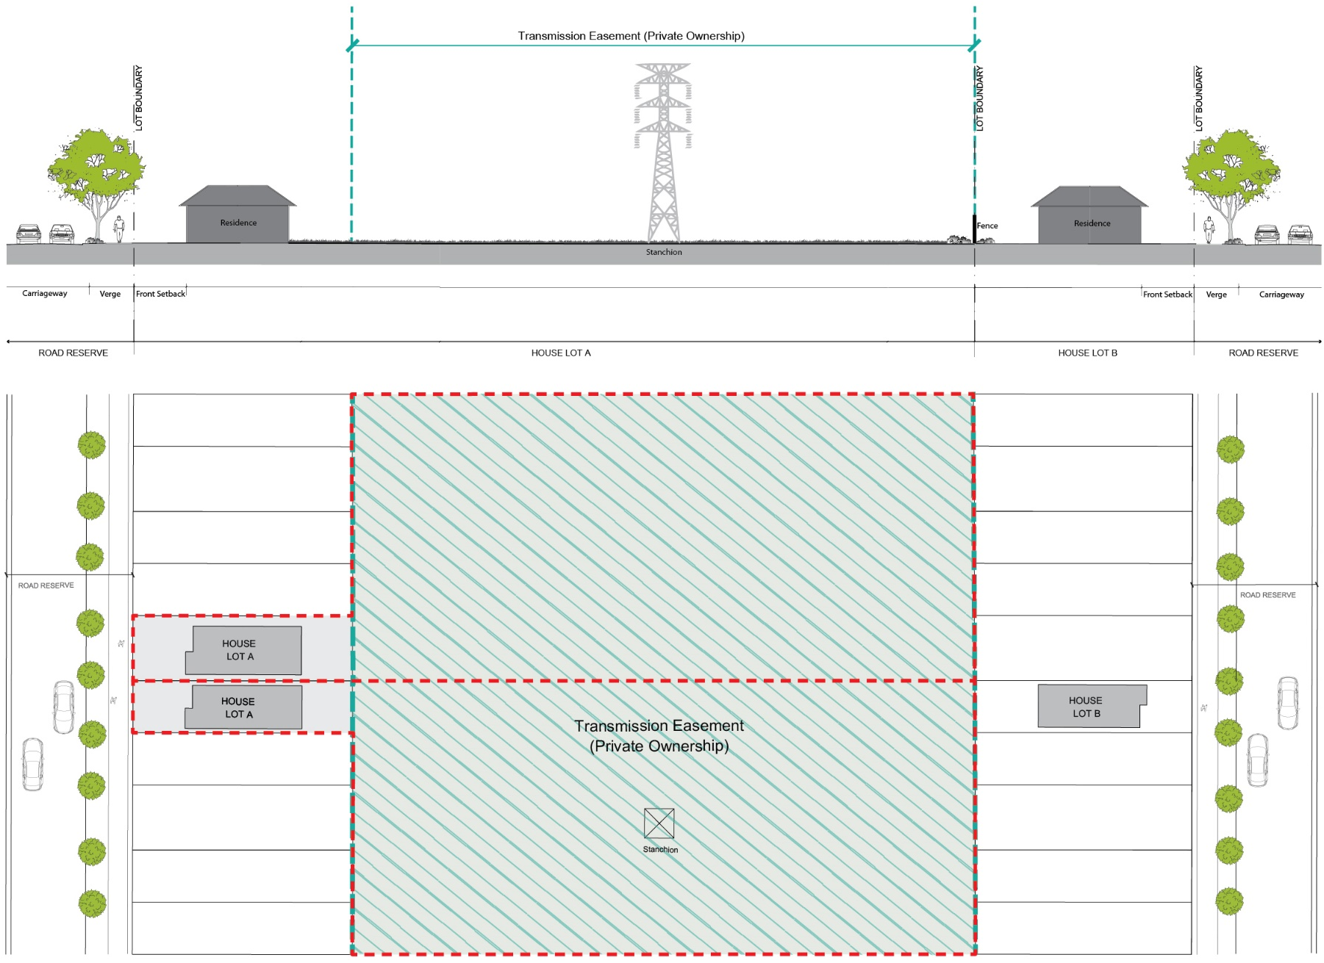
Figure 3-2: Transgrid Electricity Easement (Private Ownership)

3.2 Development near or on the Rail Corridor
Objectives
- To ensure that development on or near the rail corridor does not impact the integrity or safety of the corridor.
- To ensure reasonable standards of amenity for residential development within the vicinity of the rail corridor.
Controls
- Development within and adjacent the North South Rail Corridor must take into consideration the following documentation
  - Sydney Metro – Technical Services Sydney Metro Underground Corridor Protection Technical Guidelines;
  - Sydney Metro – Technical Services Sydney Metro at Grade and Elevated Sections Corridor Protection Guidelines; and
  - Development Near Rail Corridors and Busy Roads – Interim Guideline.
- Developments adjacent to the North South Rail Corridor must be oriented towards the street.

Where residential or sensitive use development is proposed within 100m of the North South Rail Corridor an acoustic assessment must be undertaken in accordance with Council’s Environmental Noise Policy. Where alternative noise mitigation is not proposed and residential dwellings are located within 25m of a rail corridor, dwelling noise mitigation must incorporate “Category 3” acoustic measures (or equivalent) in accordance with the Department of Planning, Industry and Environment – Development Near Rail Corridors and Busy Roads – Interim Guideline (Figure 3.3a and Appendix C). Similarly, where residential dwellings are located between 25m and 60m from a rail corridor “Category 2” acoustic measures (or equivalent) in accordance with the Department of Planning Industry and Environment – Development Near Rail Corridors and Busy Roads – Interim Guideline (Figure 3.3a and Appendix C).

3.3 Road Cross Sections
Objectives
- To improve accessibility and walkability within streets.
- To ensure streets contribute to the liveability of the urban area.
- To increase street tree canopy cover through the provision of increased blisters (flex zones) and wider verges.
- To ensure “Green Link” streets promote green infrastructure within residential neighbourhoods and increase connectivity between Neighbourhood Parks.
Controls
- The design and construction of streets are to be consistent with the relevant designs in Figures 3-4 to 3-11.
- The corresponding street types are to be located as identified in Figure 2-12 Precinct Road Hierarchy.
- For “Green Link” streets, as identified in Figure 2-12 Precinct Road Hierarchy, the driveway crossovers of the green link verge are to be minimised.
- Flex zones provide increased area of verge as shown in Figure 3-12: Typical Flex Zone Design and are to be incorporated at intersections and regular intervals within the street where it is determined they are needed to perform the following functions:
  - Reduce crossing distances for pedestrians at intersections;
  - Define kerb side parking and travel lanes;
  - Assist with traffic calming; and
  - Provide increased opportunity for tree planting and canopy cover.
- Street trees are to be of a species that maximise height and canopy cover, with larger and/or additional trees provided within the flex zones.
- Paths are to be provided on both sides of all streets inclusive of a sharepath where directed by Figure 2-12.
- Street tree plantings must be in accordance with the Tranche 41 Tree Strategy (August 2021) – JMD design .

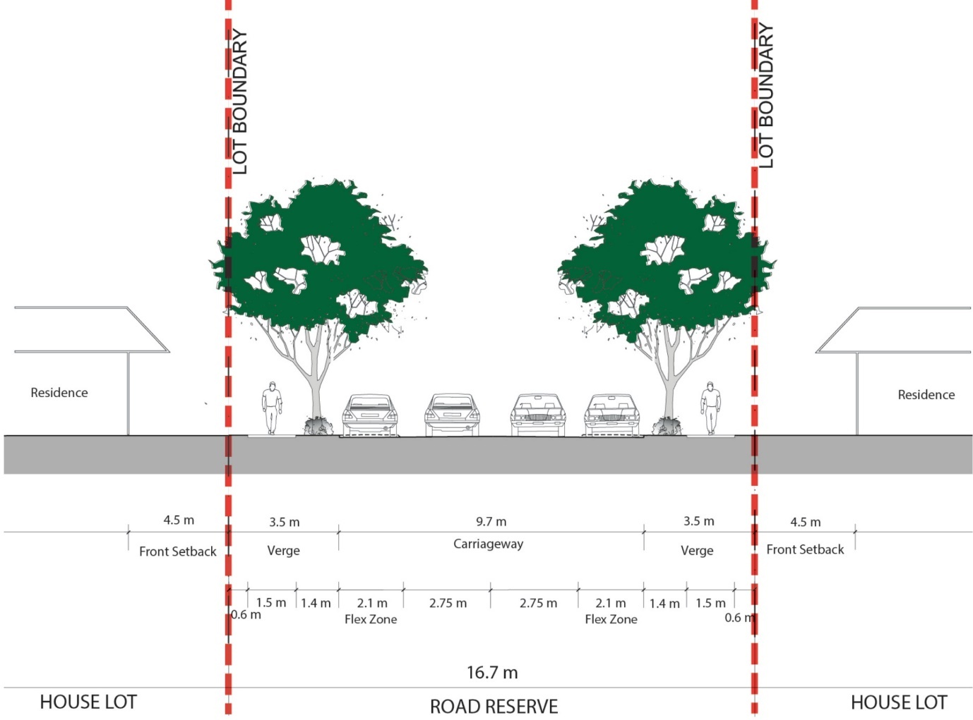
Figure 3-3: Local Street Cross Section (Typical)
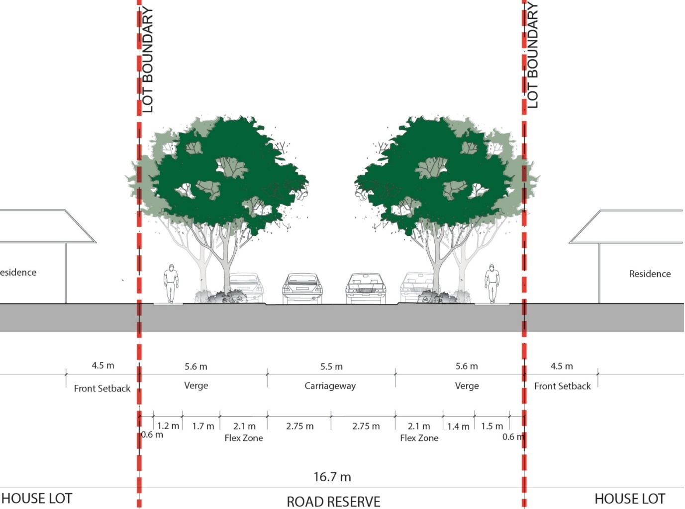
Figure 3-4: Local Street Cross Section (Flex Zone)
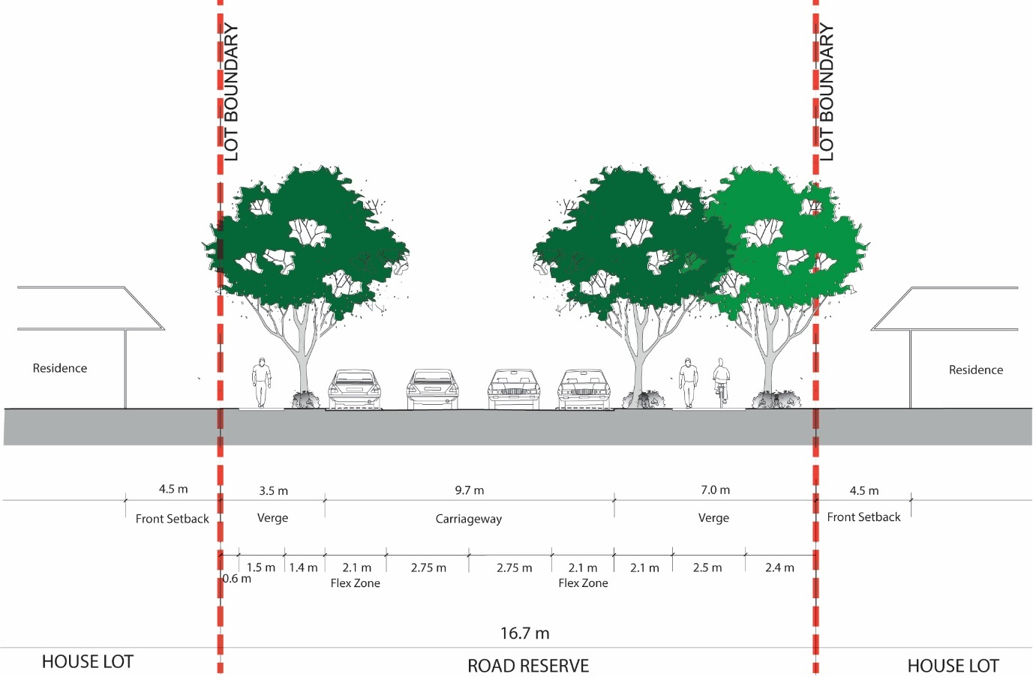
Figure 3-5: Green Link Street Cross Section (Typical)

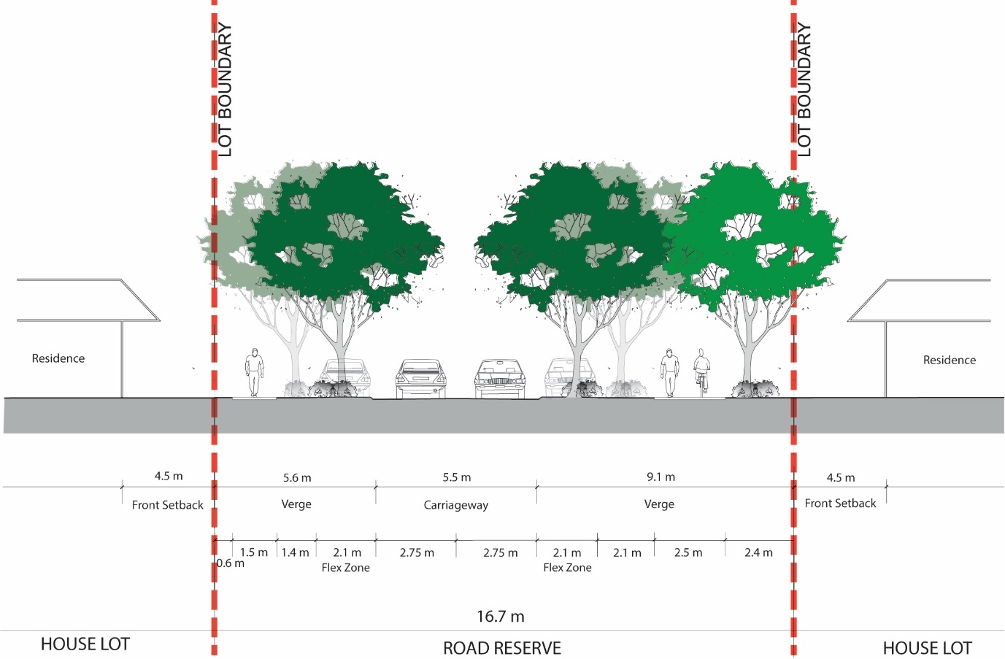
Figure 3-6: Green Link Street Cross Section (Flex Zone)

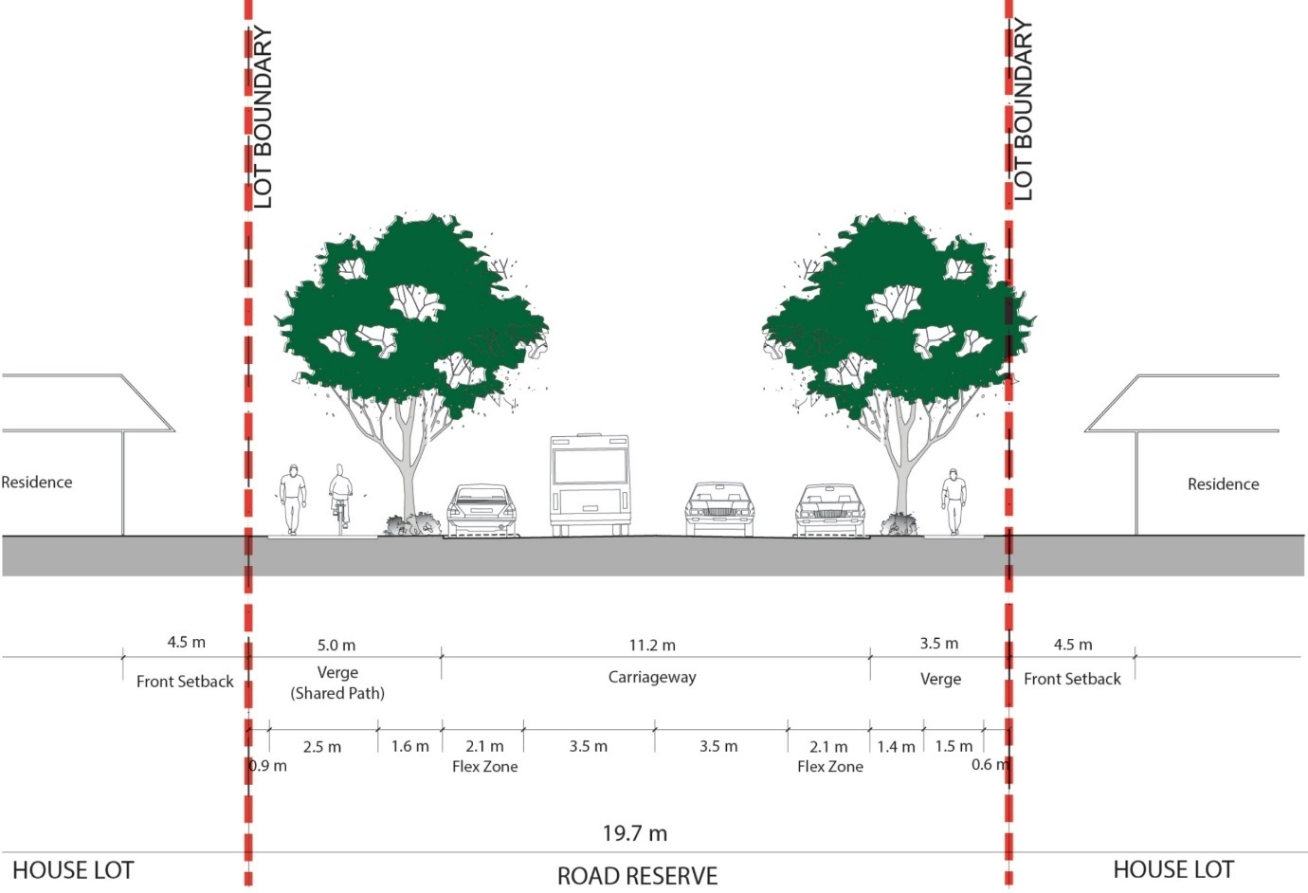
Figure 3-7: Collector Road Cross Section – No Median (Typical)
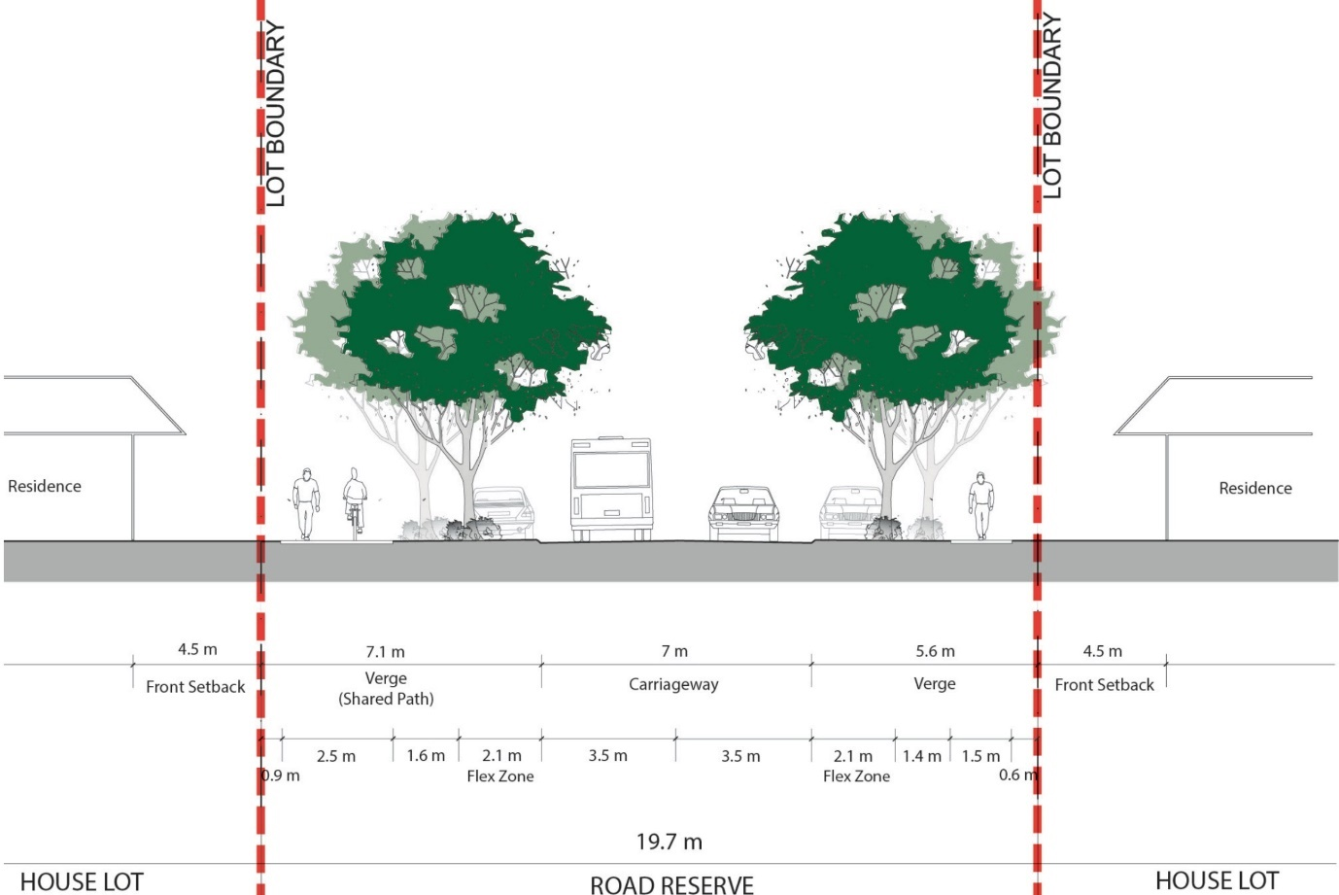
Figure 3-8: Collector Road Cross Section – No Median (Flex Zone)

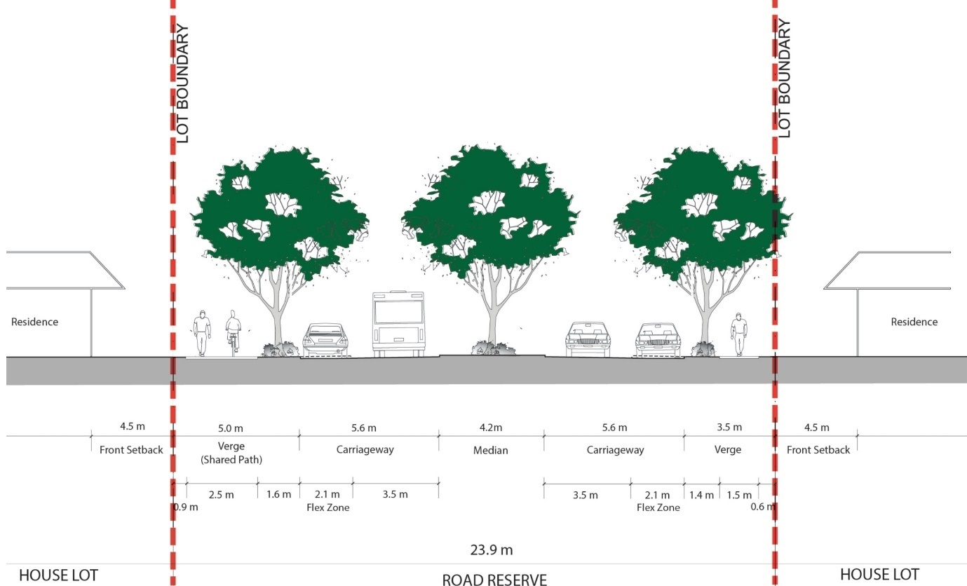
Figure 3-9: Collector Road Cross Section – Median (Typical)
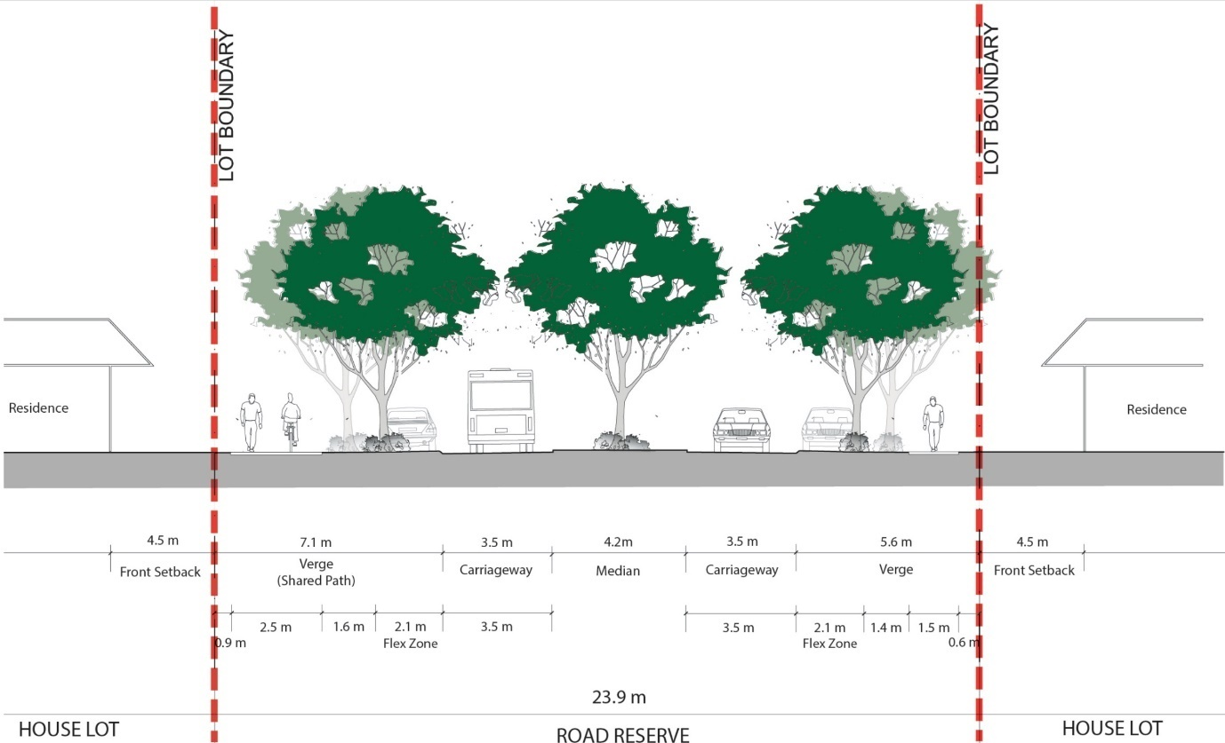
Figure 3-10: Collector Road Cross Section – Median (Flex Zone)

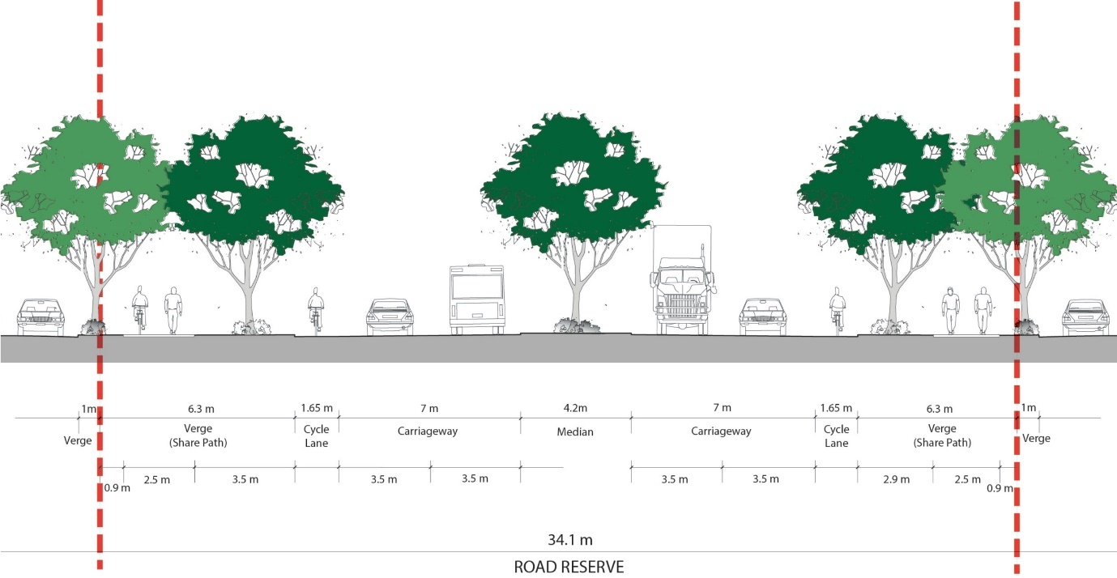
Figure 3-11: Sub-Arterial Road Cross Section (On Road Cycle Lane)
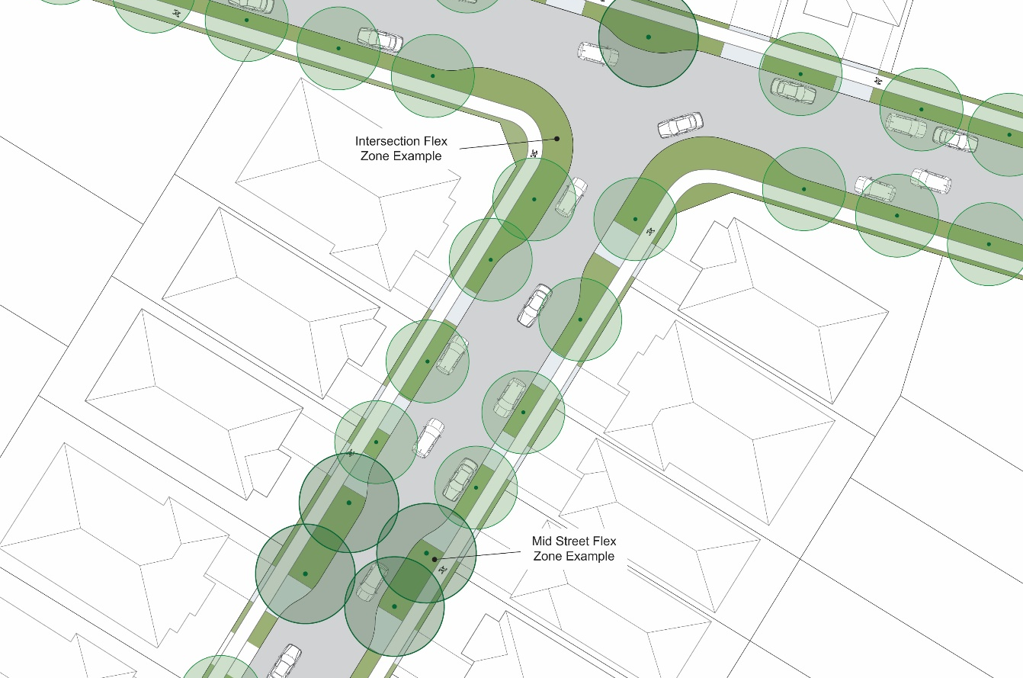
Figure 3-12: Typical Flex Zone Design

